Module End Exam

Create a Linux EC2 instance. Create a html page & make it public

Ans. **Go to AWS login page**

**Enter Email > Press Enter**

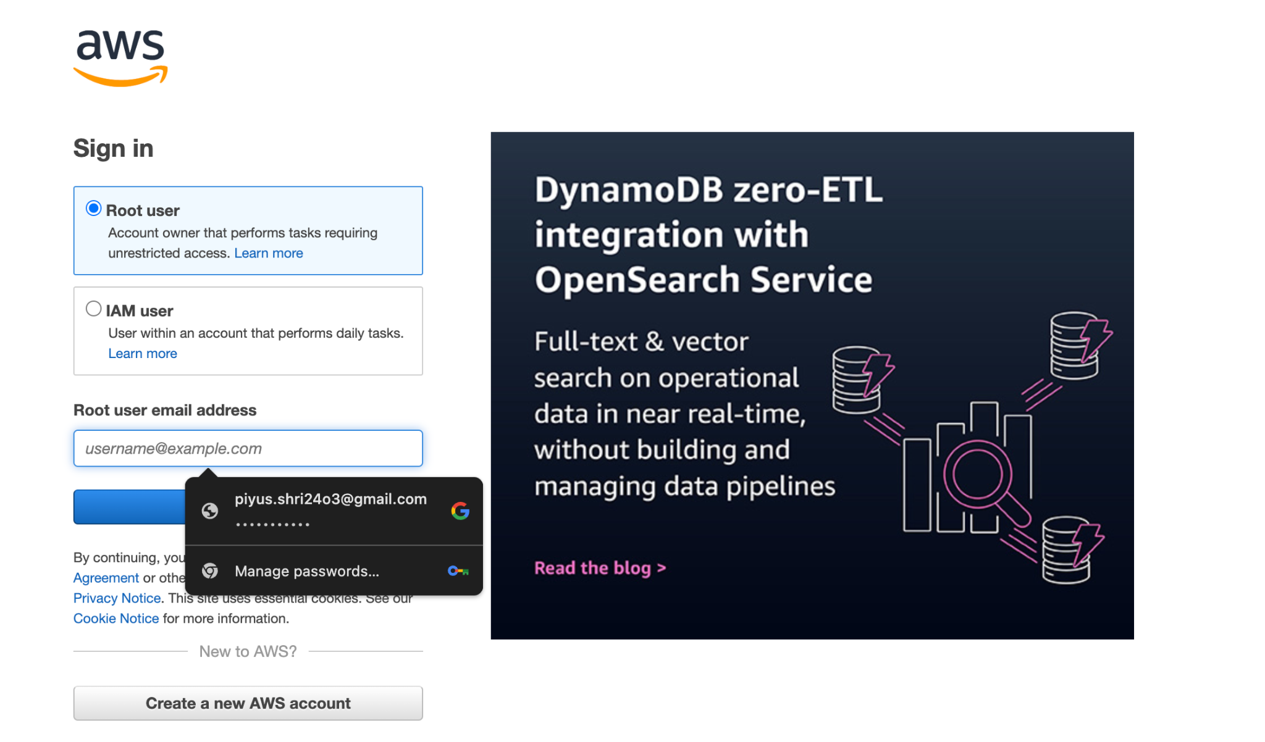

**Enter code displayed > Submit**

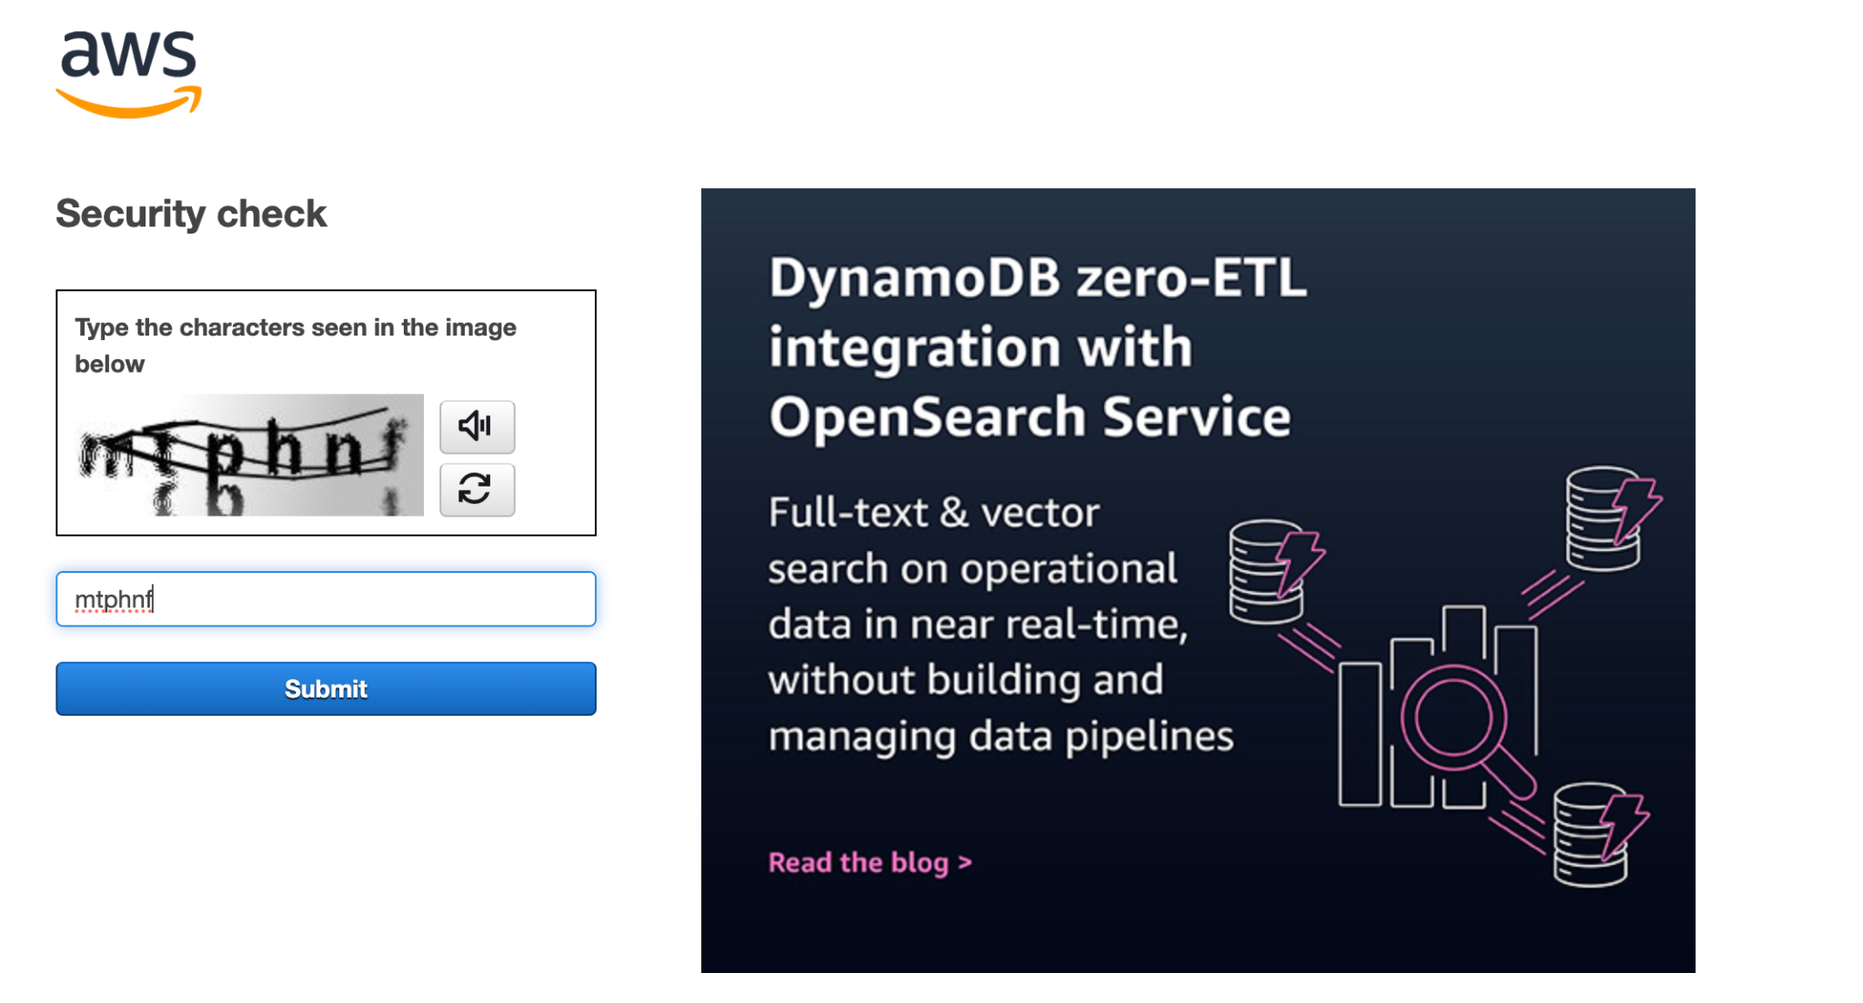

**Enter Password > click on Sign In**

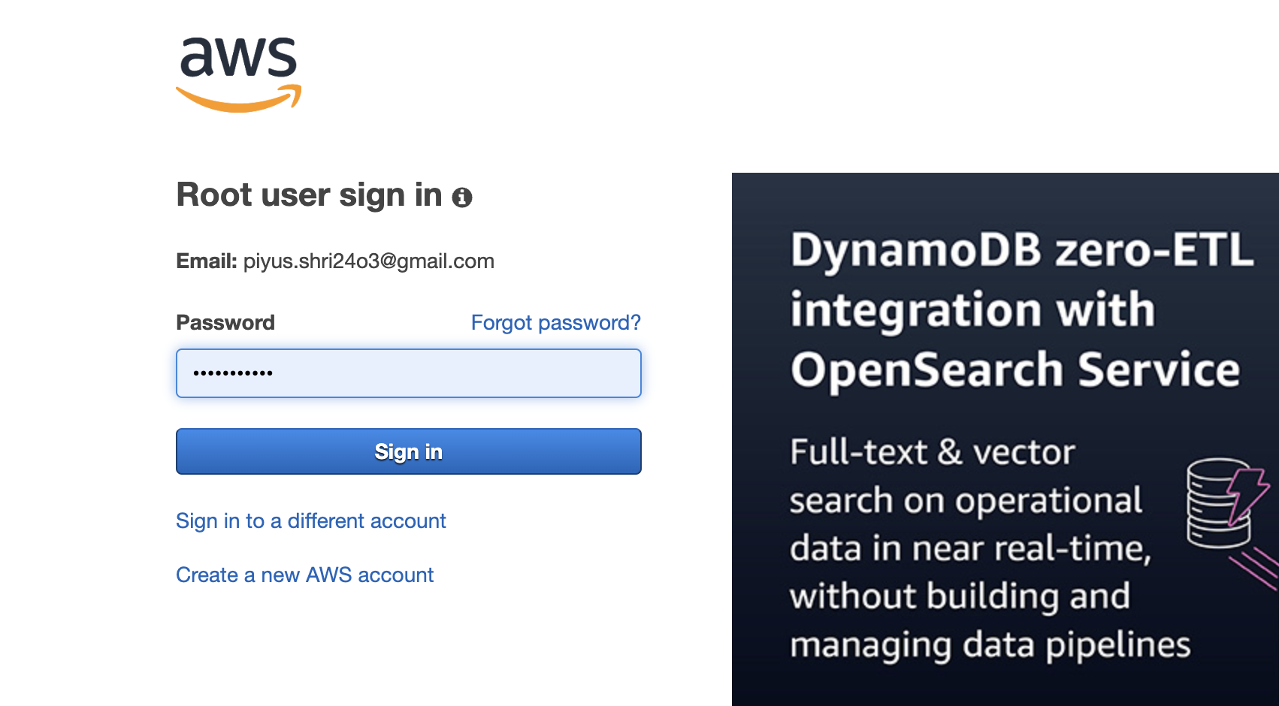

**Enter MFA Code seen in Authenticator App on your Phone > Submit**

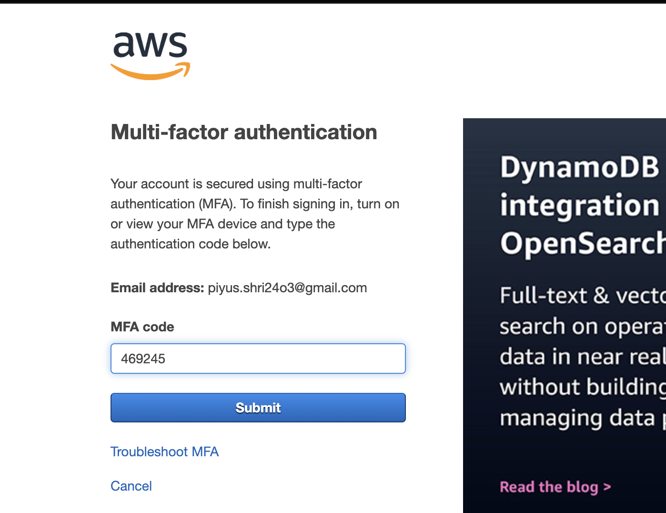

**We Land on this page > Click EC2 in recently visited**

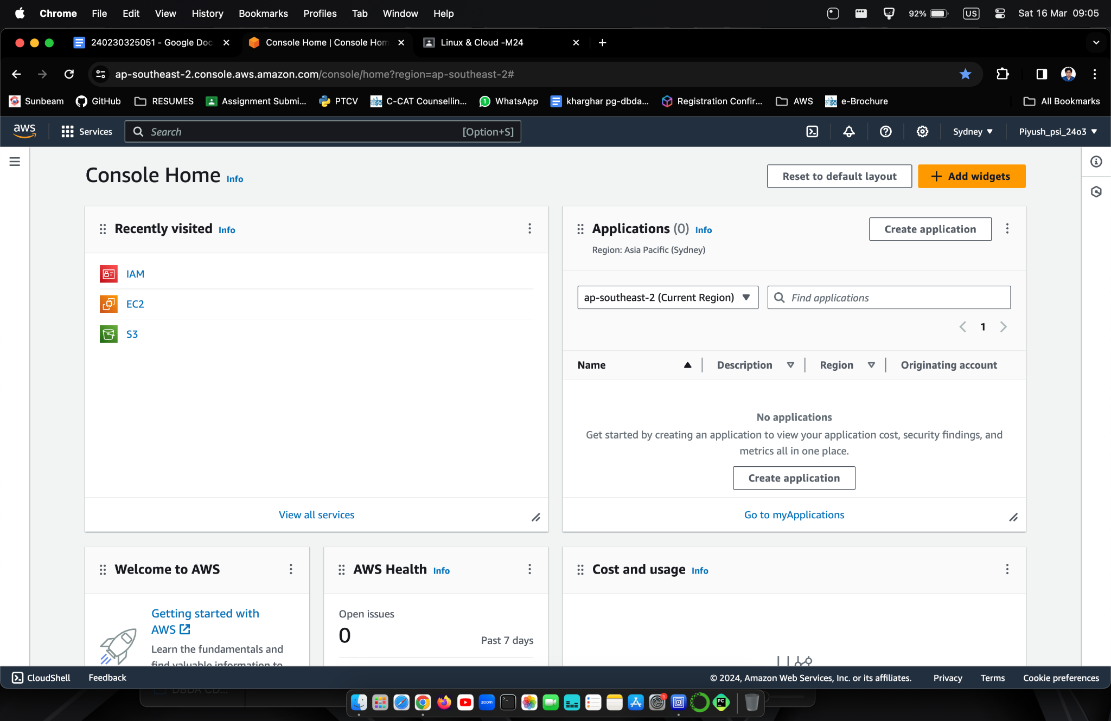

**After Click below is next screen > Click on Launch Instance**

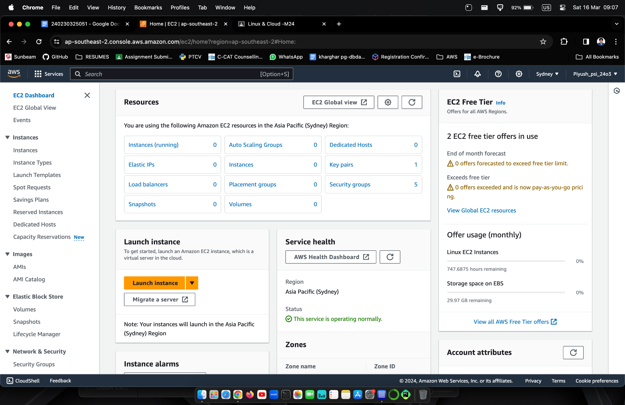

**On below screen enter name of your instance in field provided. Name entered should be unique. I entered "piyush24"**

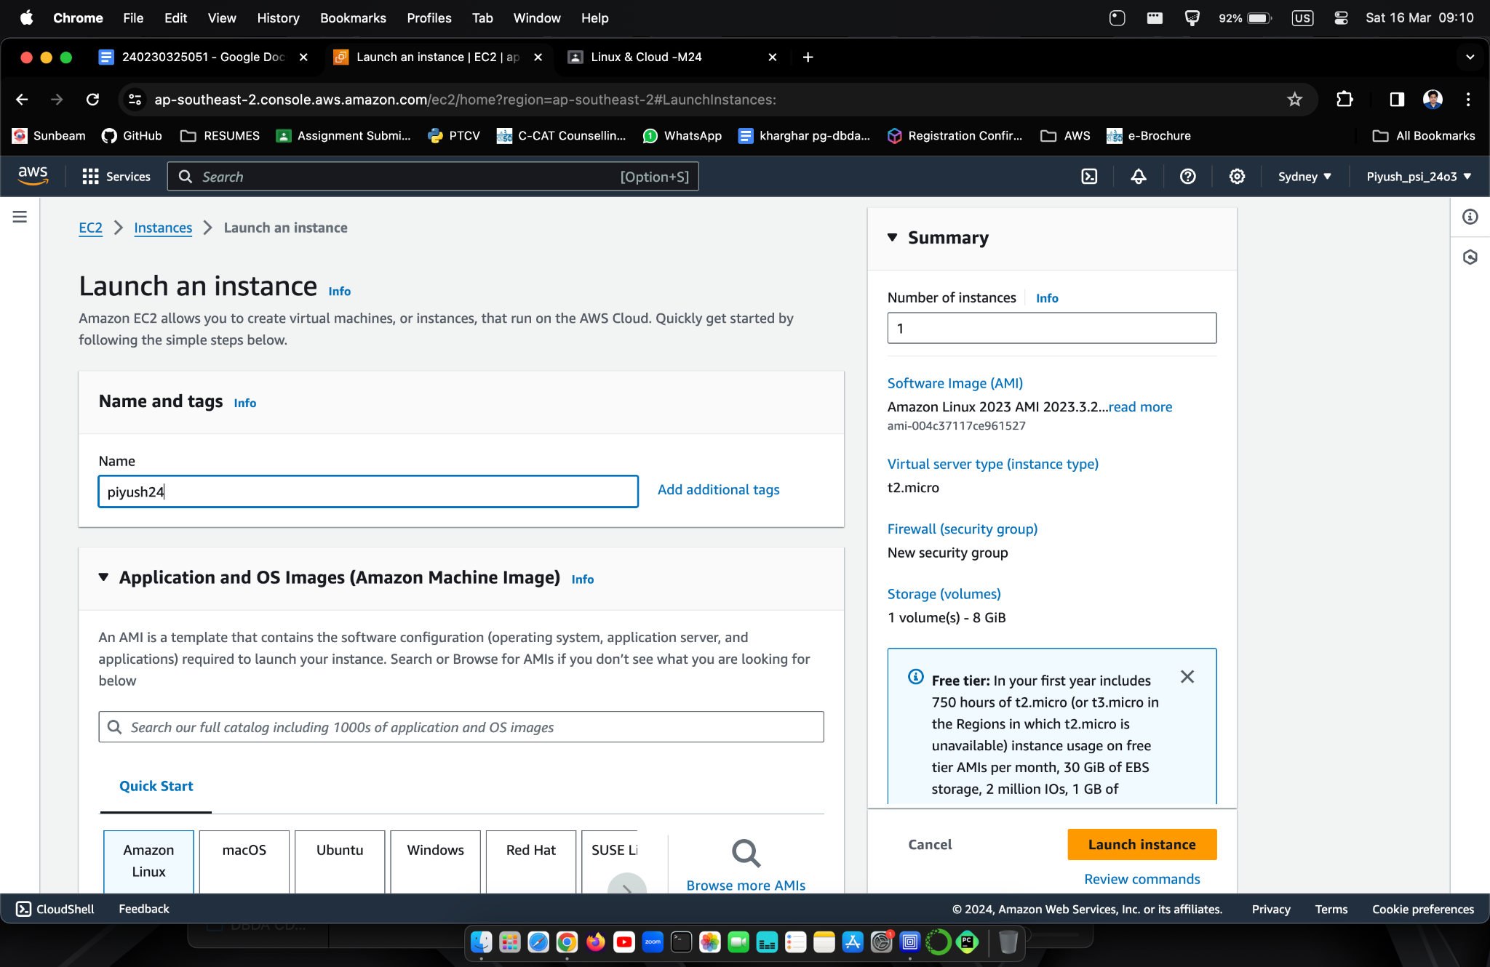

**Scroll down to Key Pair (Login) > Create New Key Pair**

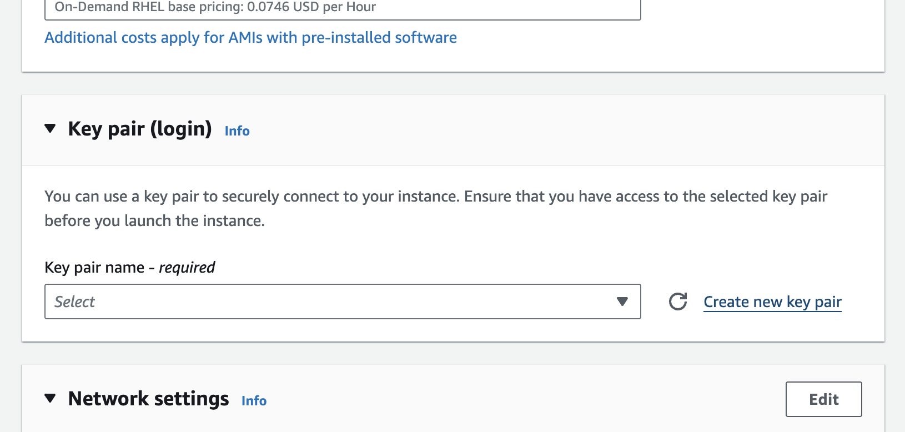

**Popup appears > Fill name of your key. I entered "key1"**

**Select .pem option > Create key pair**

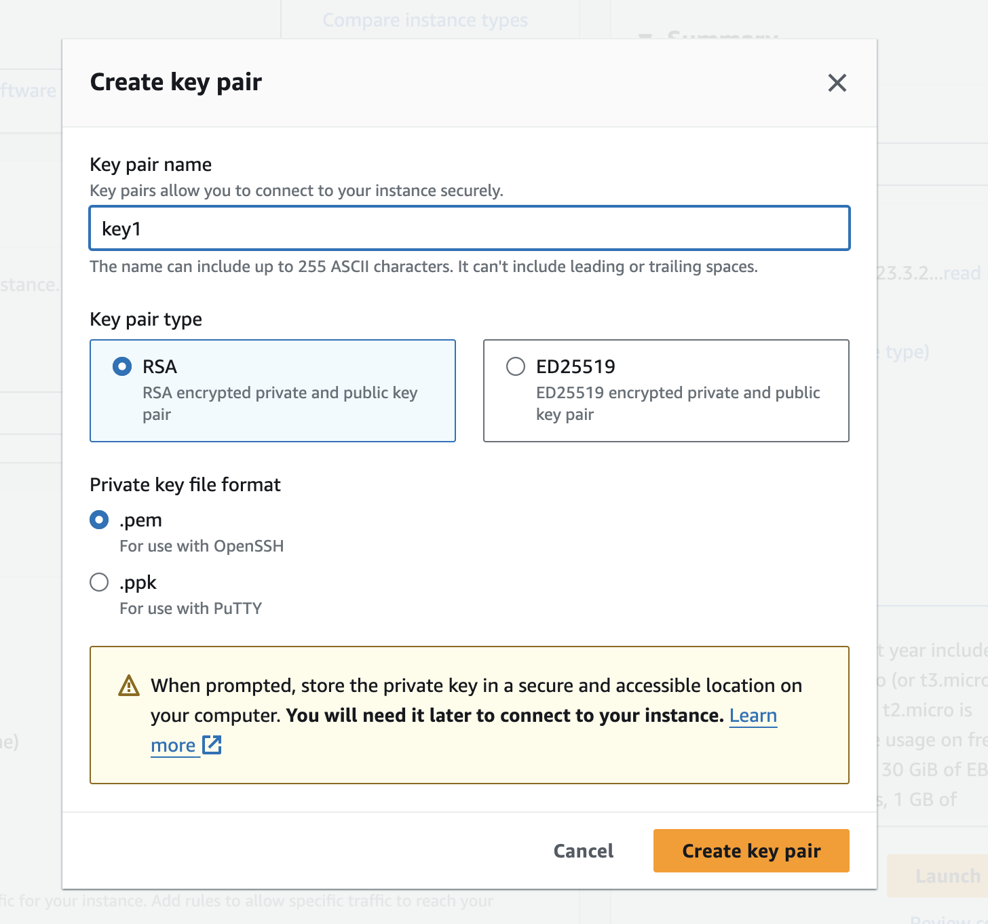

**Download key in home directory. Here it is key1.pem**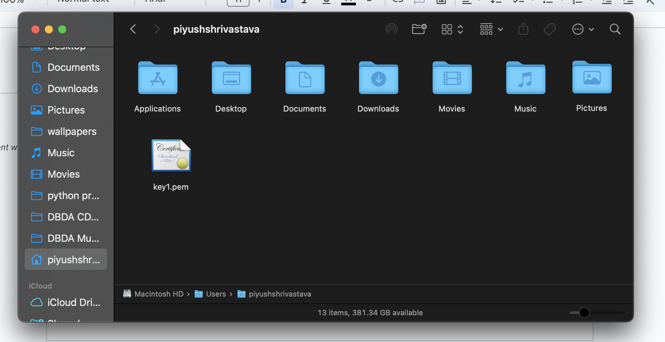

**Scroll down and Select all 3 check boxes**

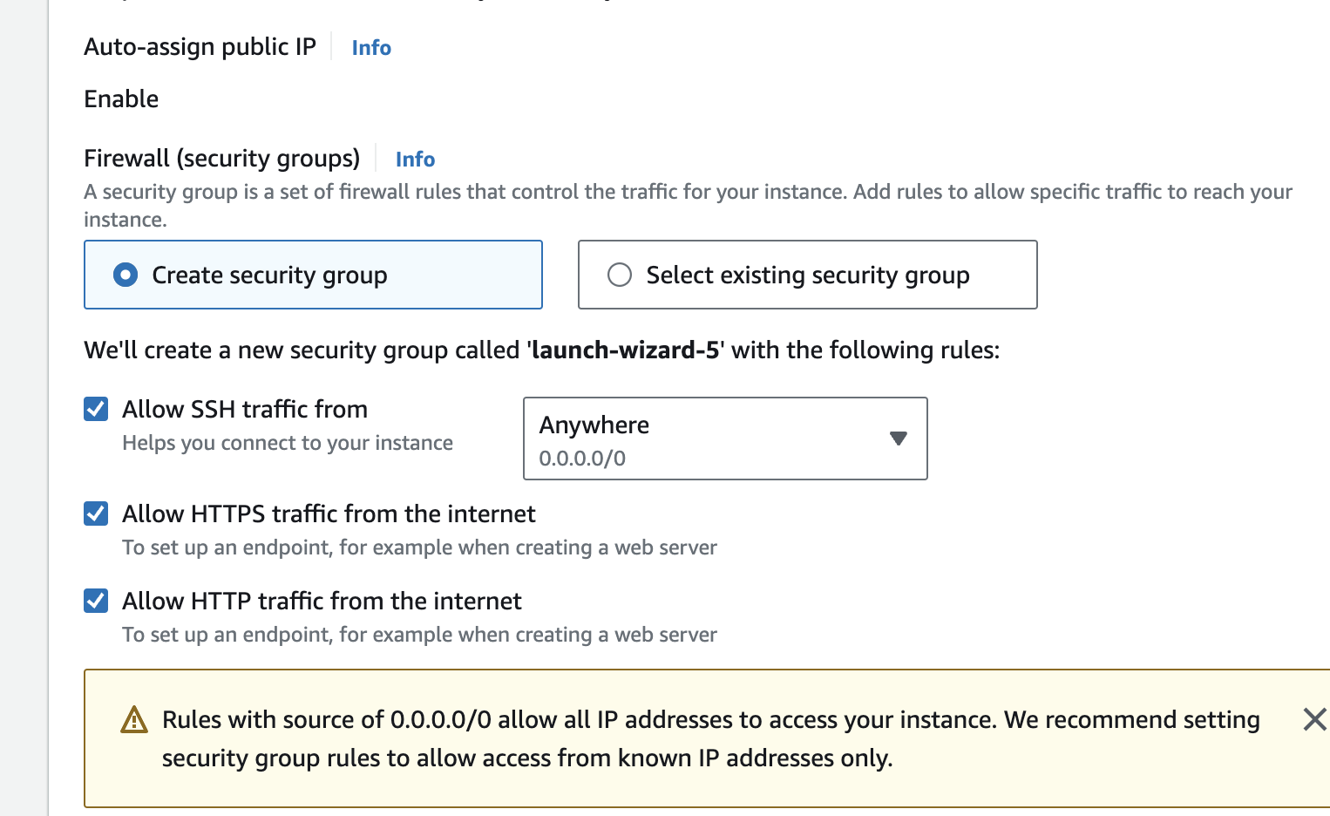

**Click Launch Instance**

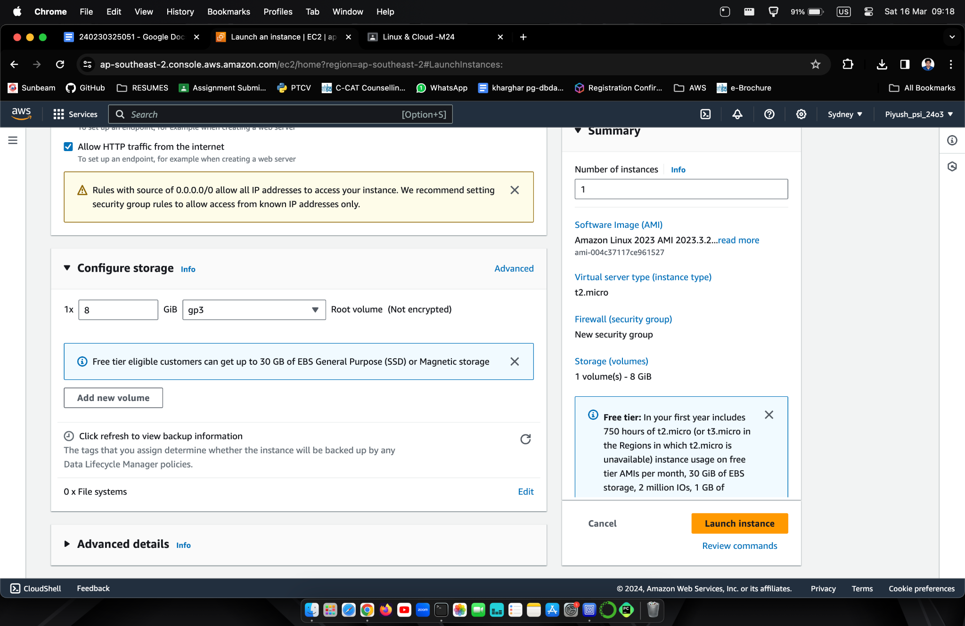

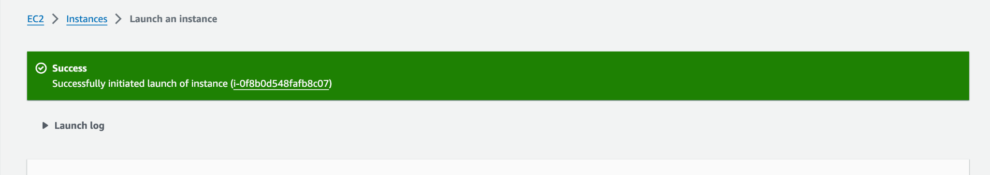

**Click on Instances in top left**

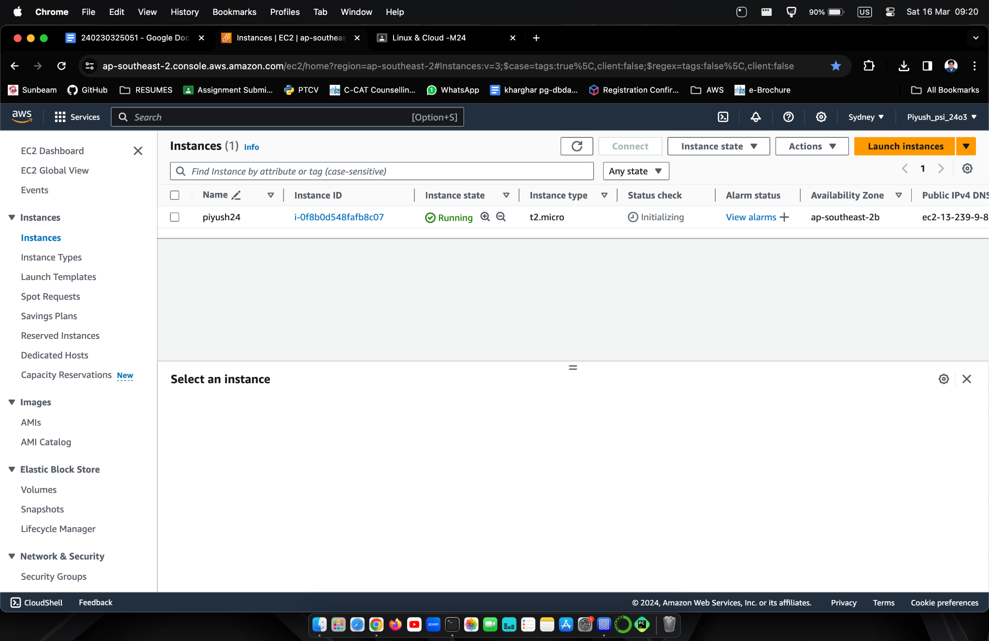

**Click on Instance ID and Copy Public IPv4 address**

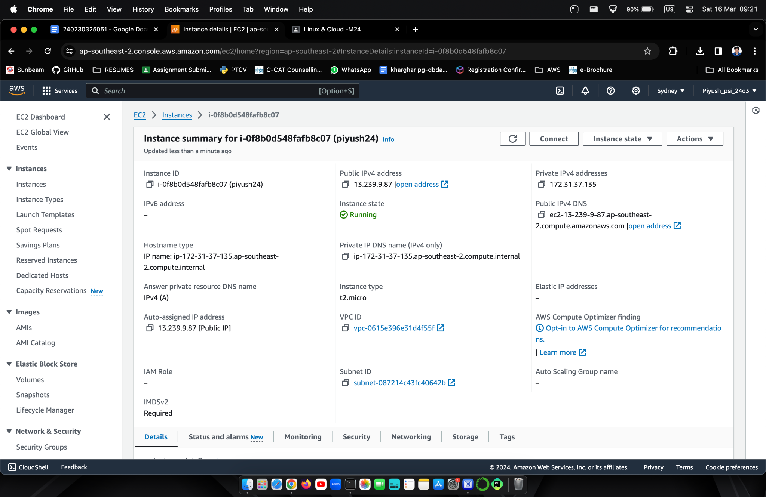

**Open Terminal and type commands**

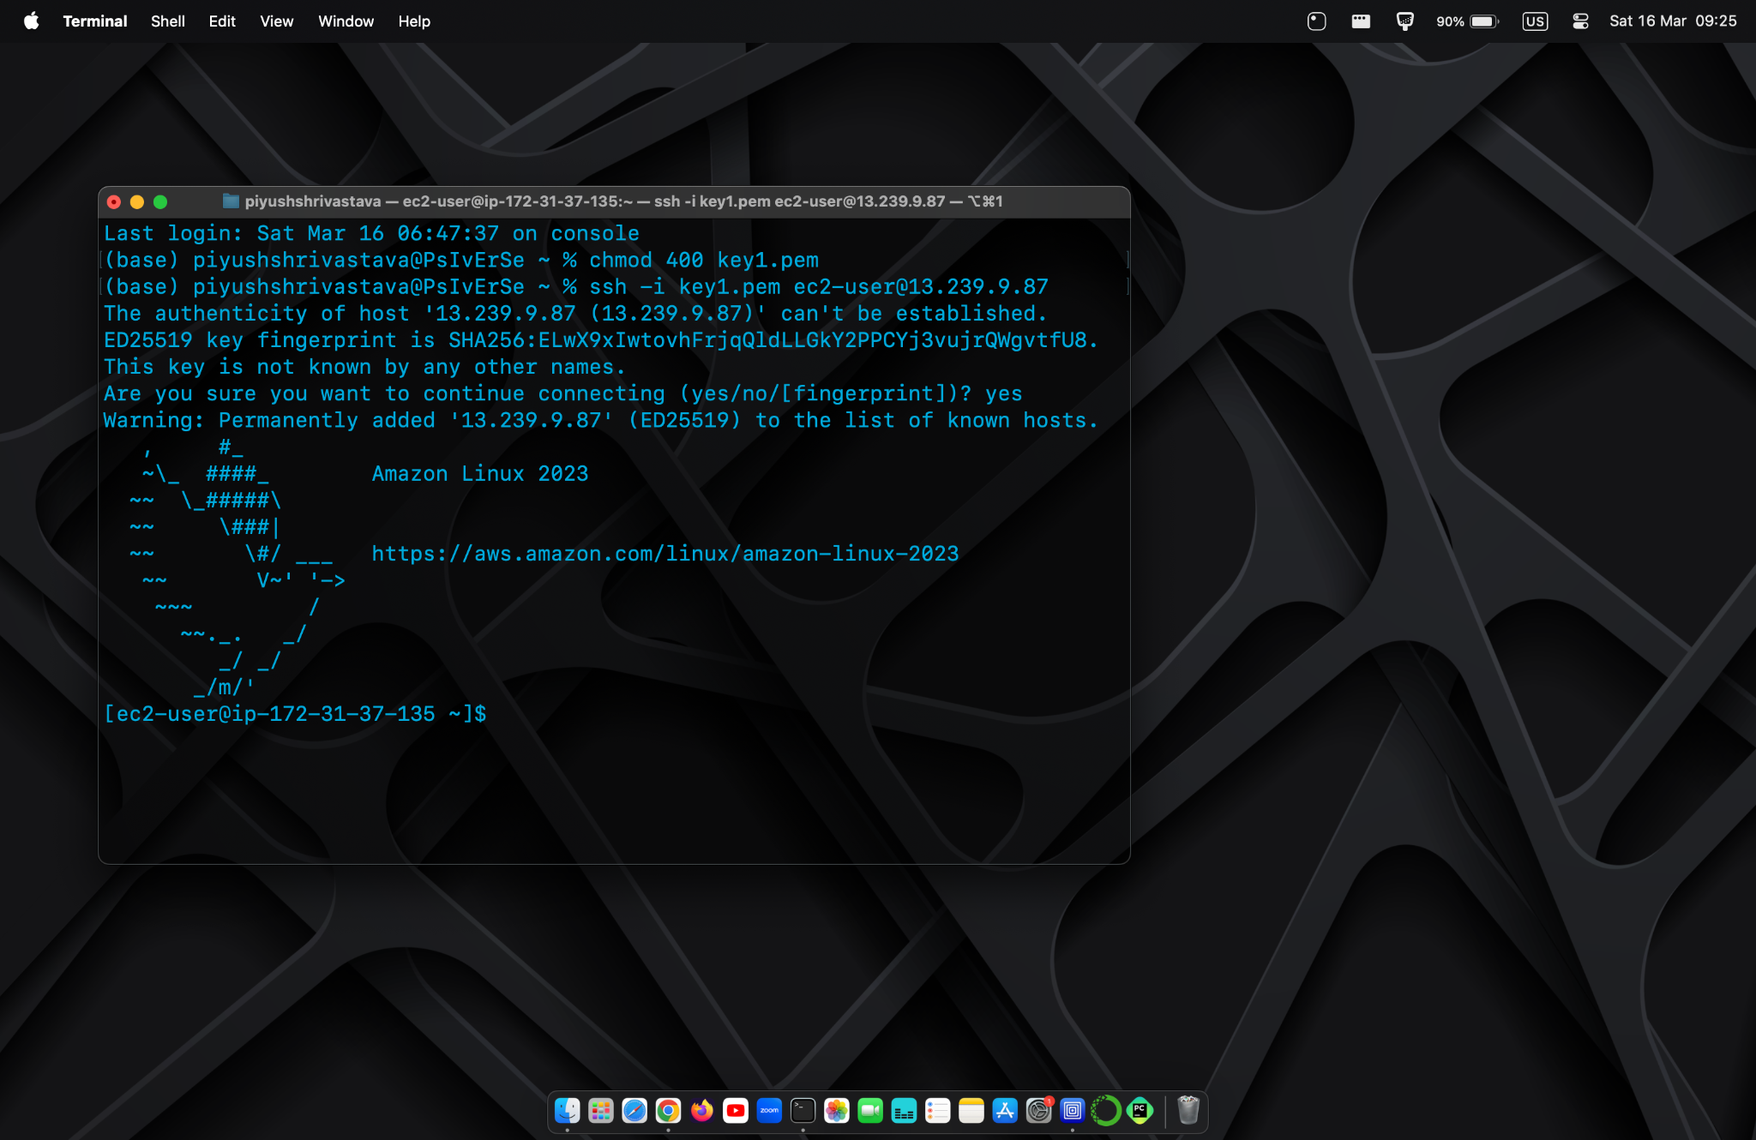

**Type Sudo -i > yum install -y > yum install httpd -y >**

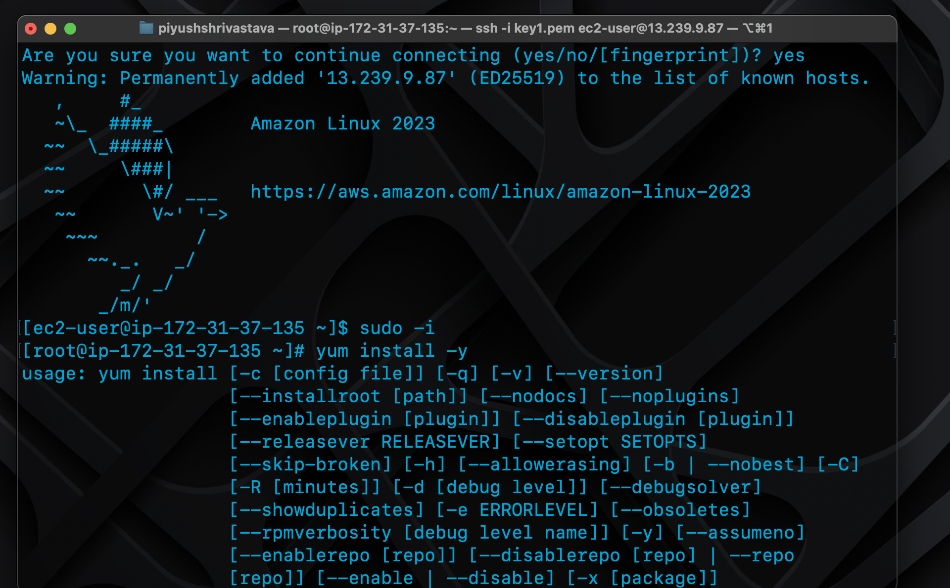

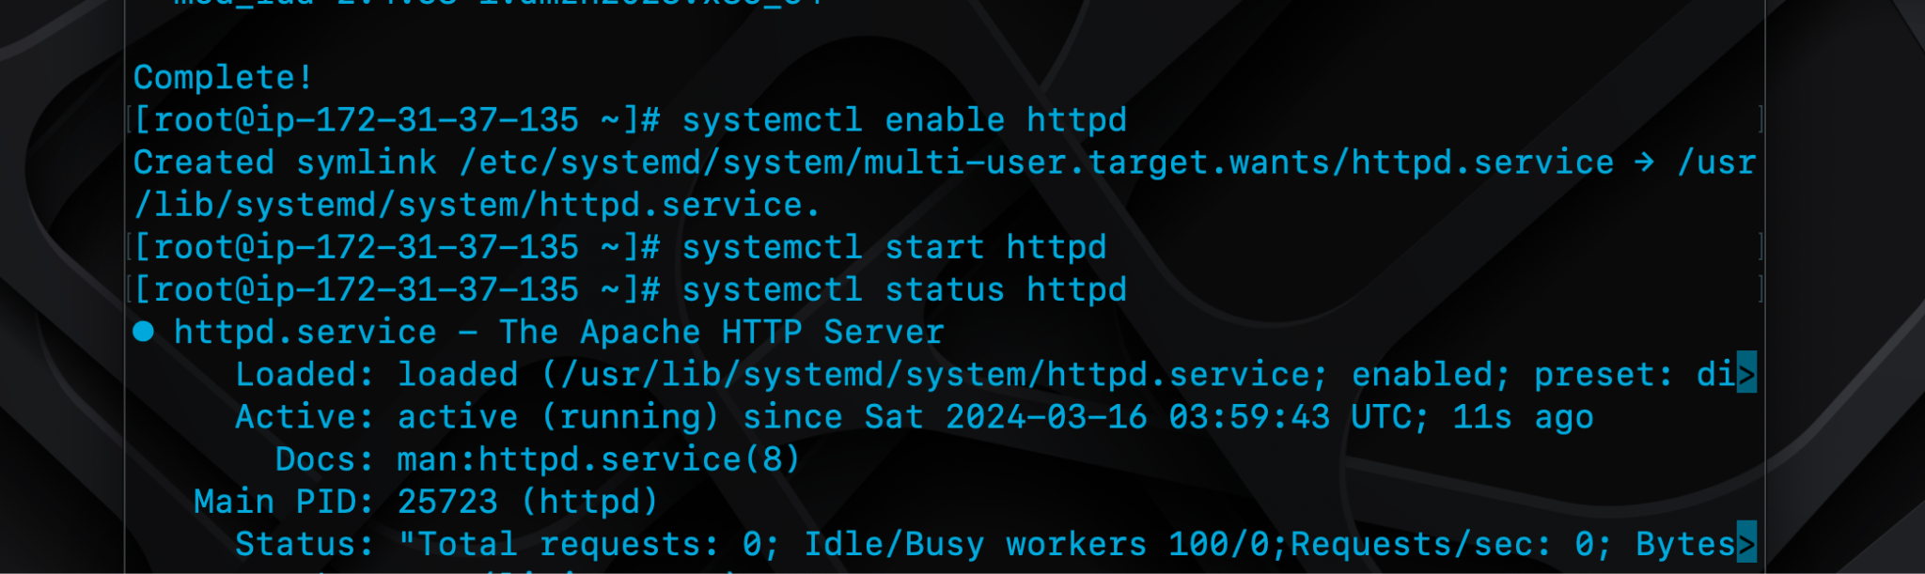

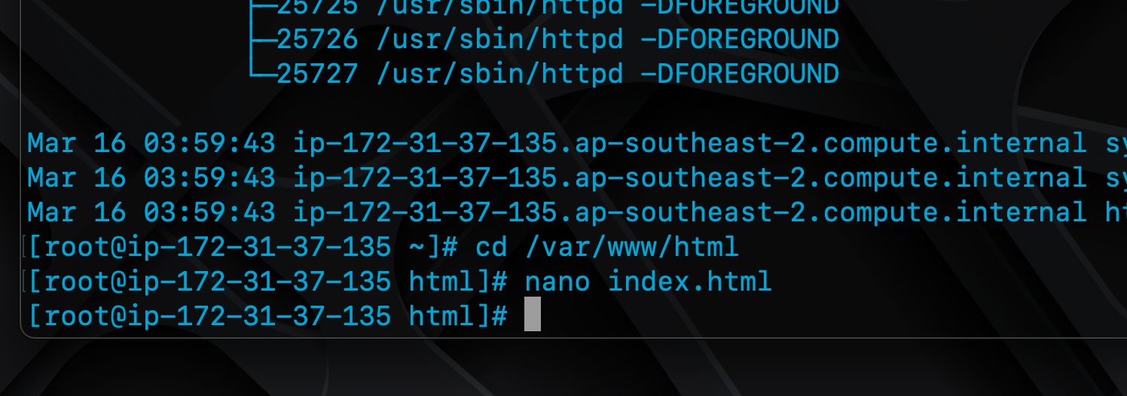

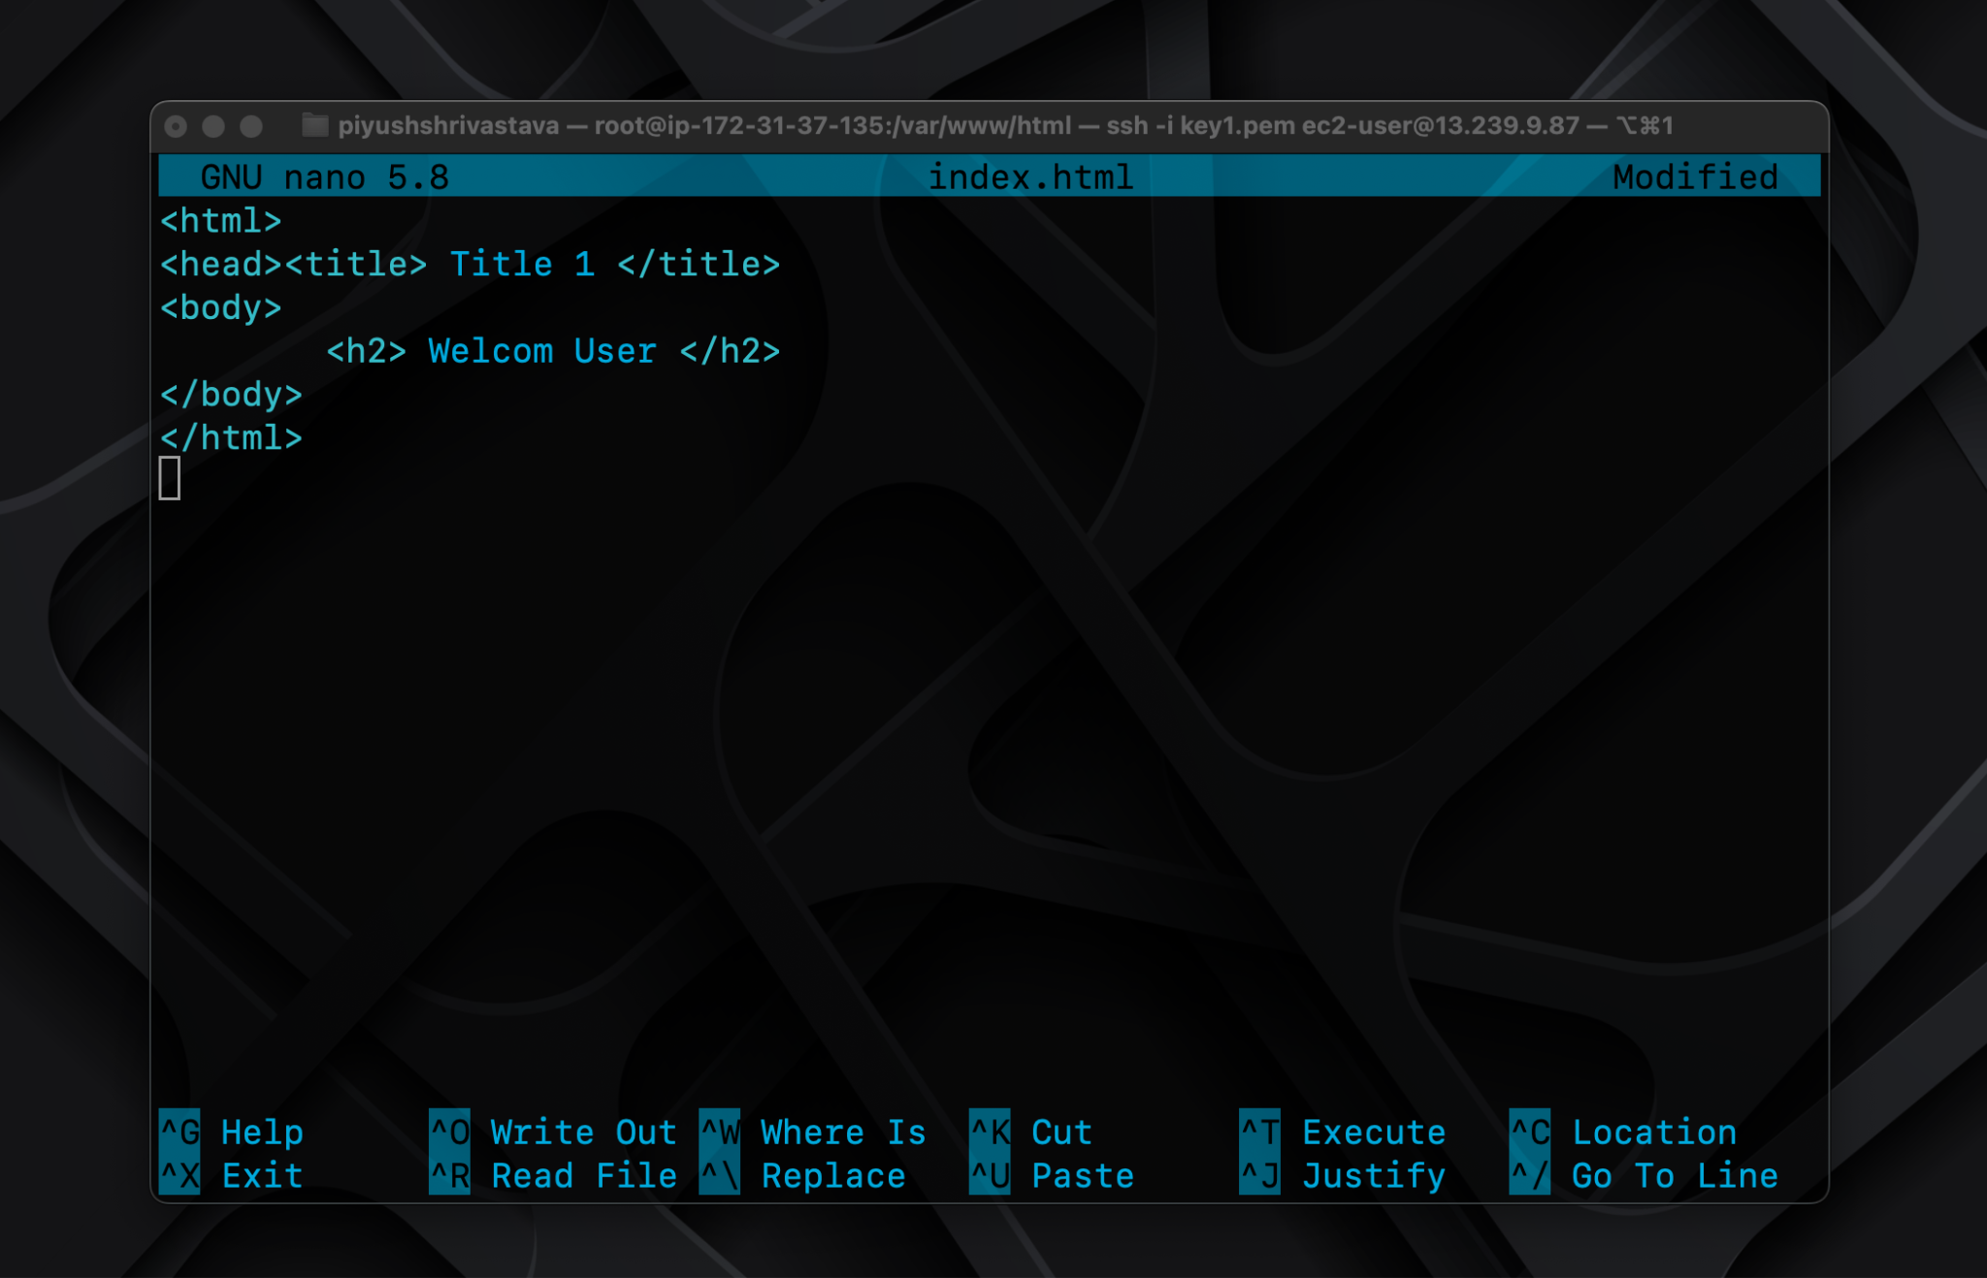

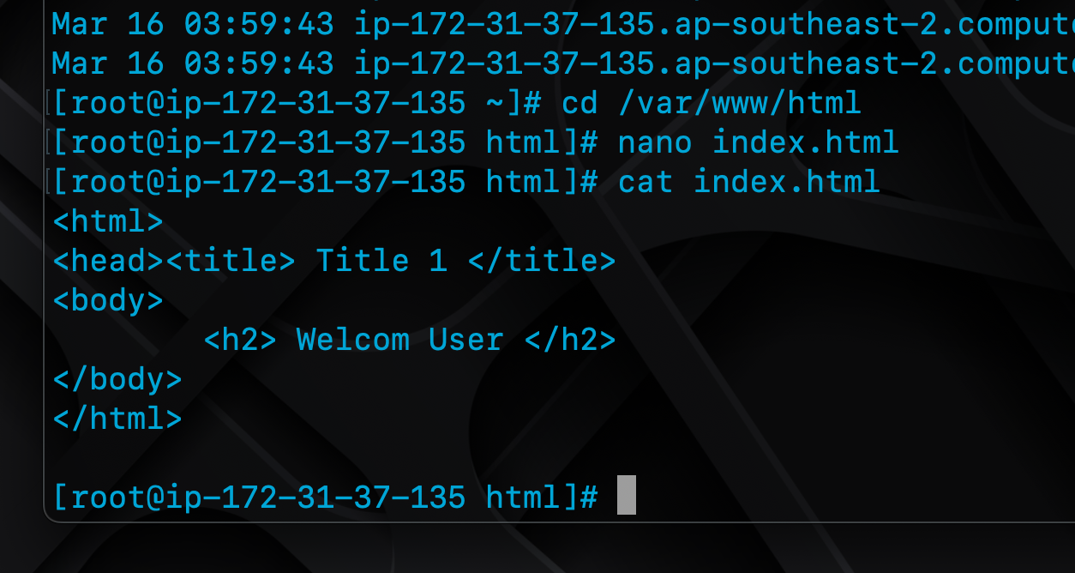

**Go to Web Browser**

**Click on Open Address Since my chrome dosen't allos I opened it in Safari**

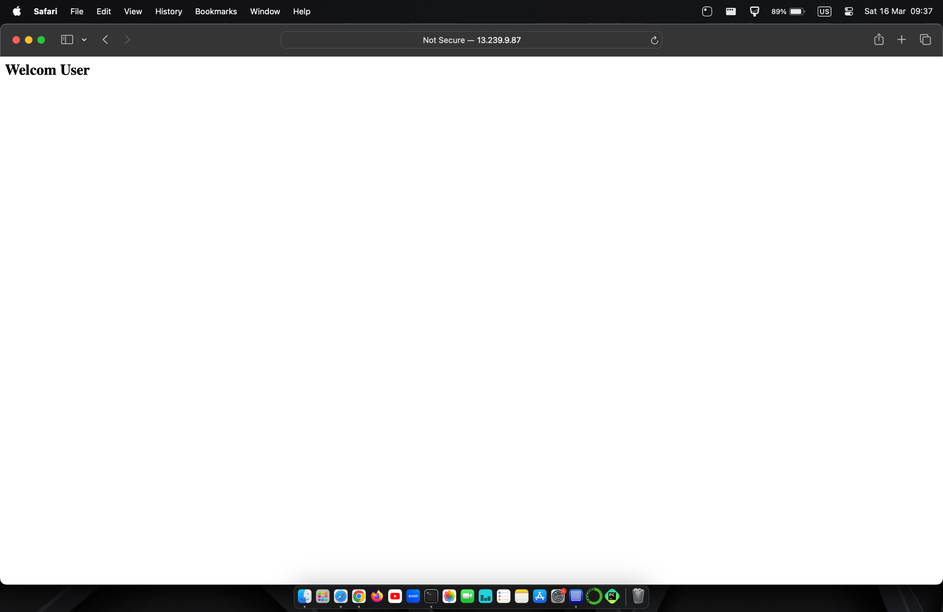

**2. Create VPC**

**Ans**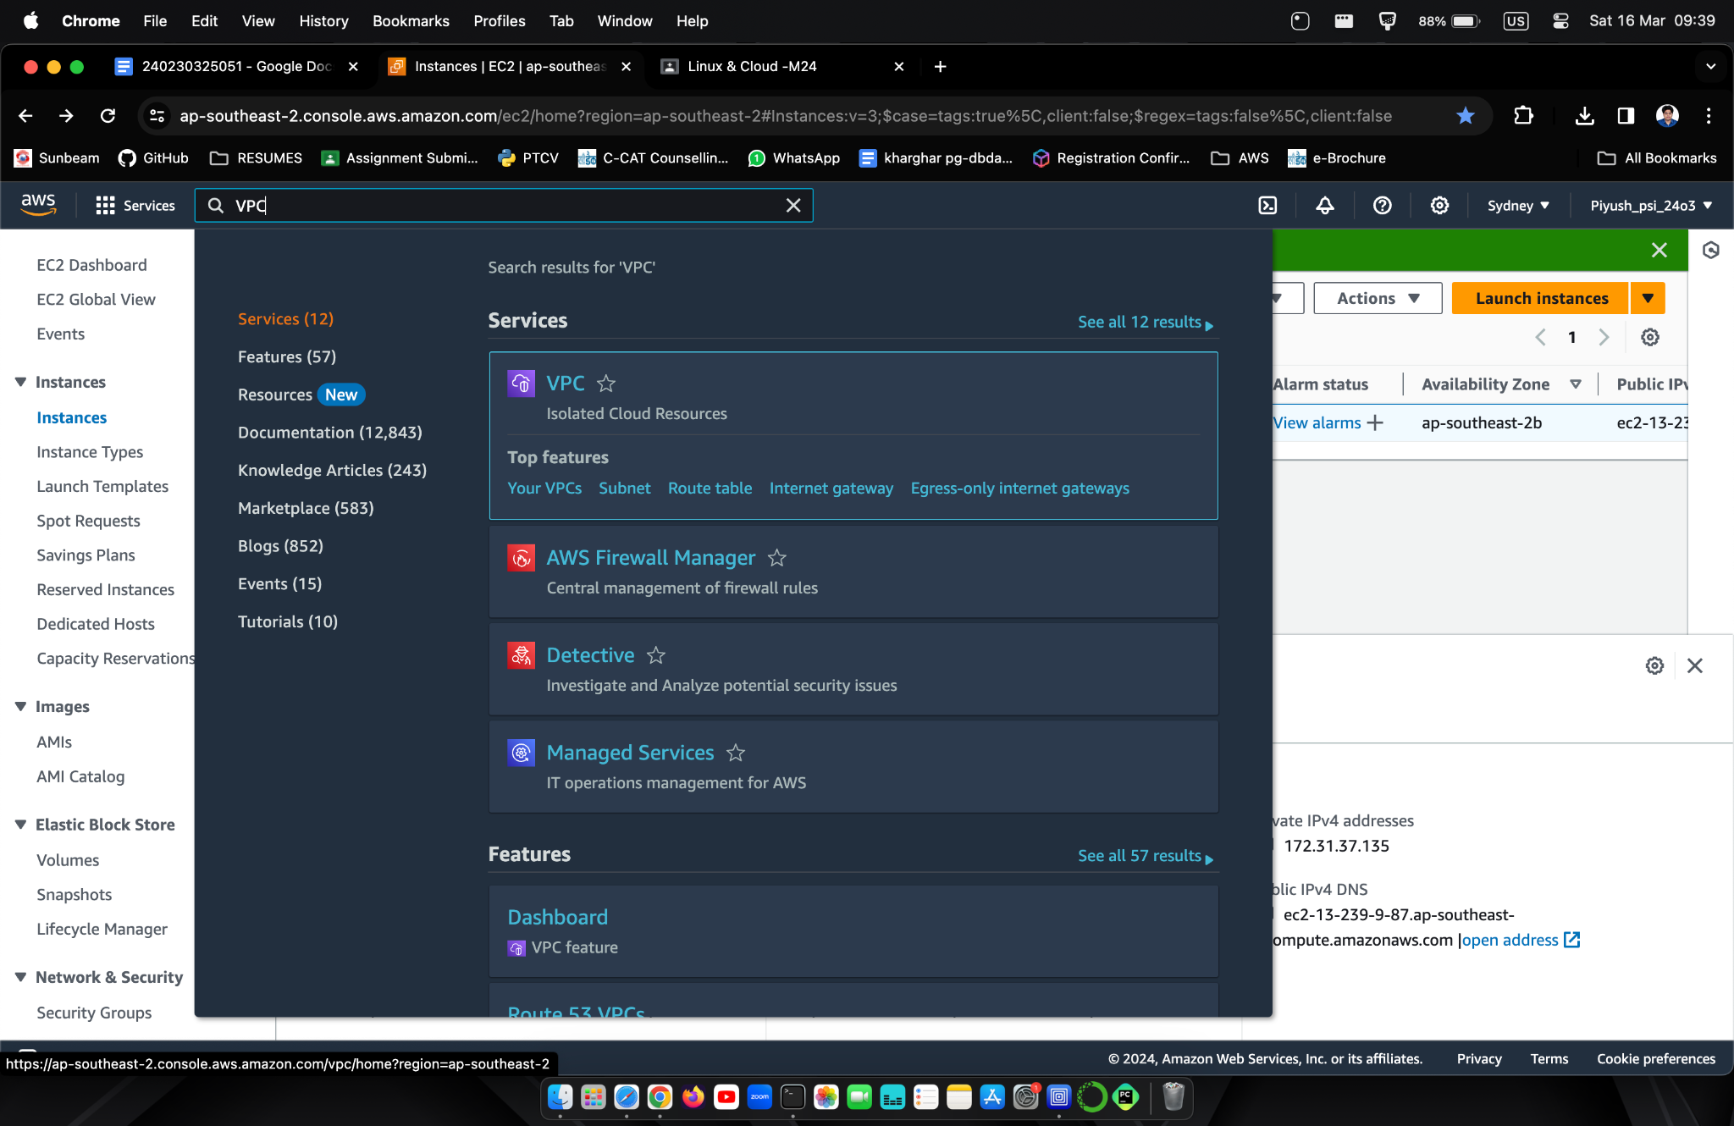

**Create VPC**

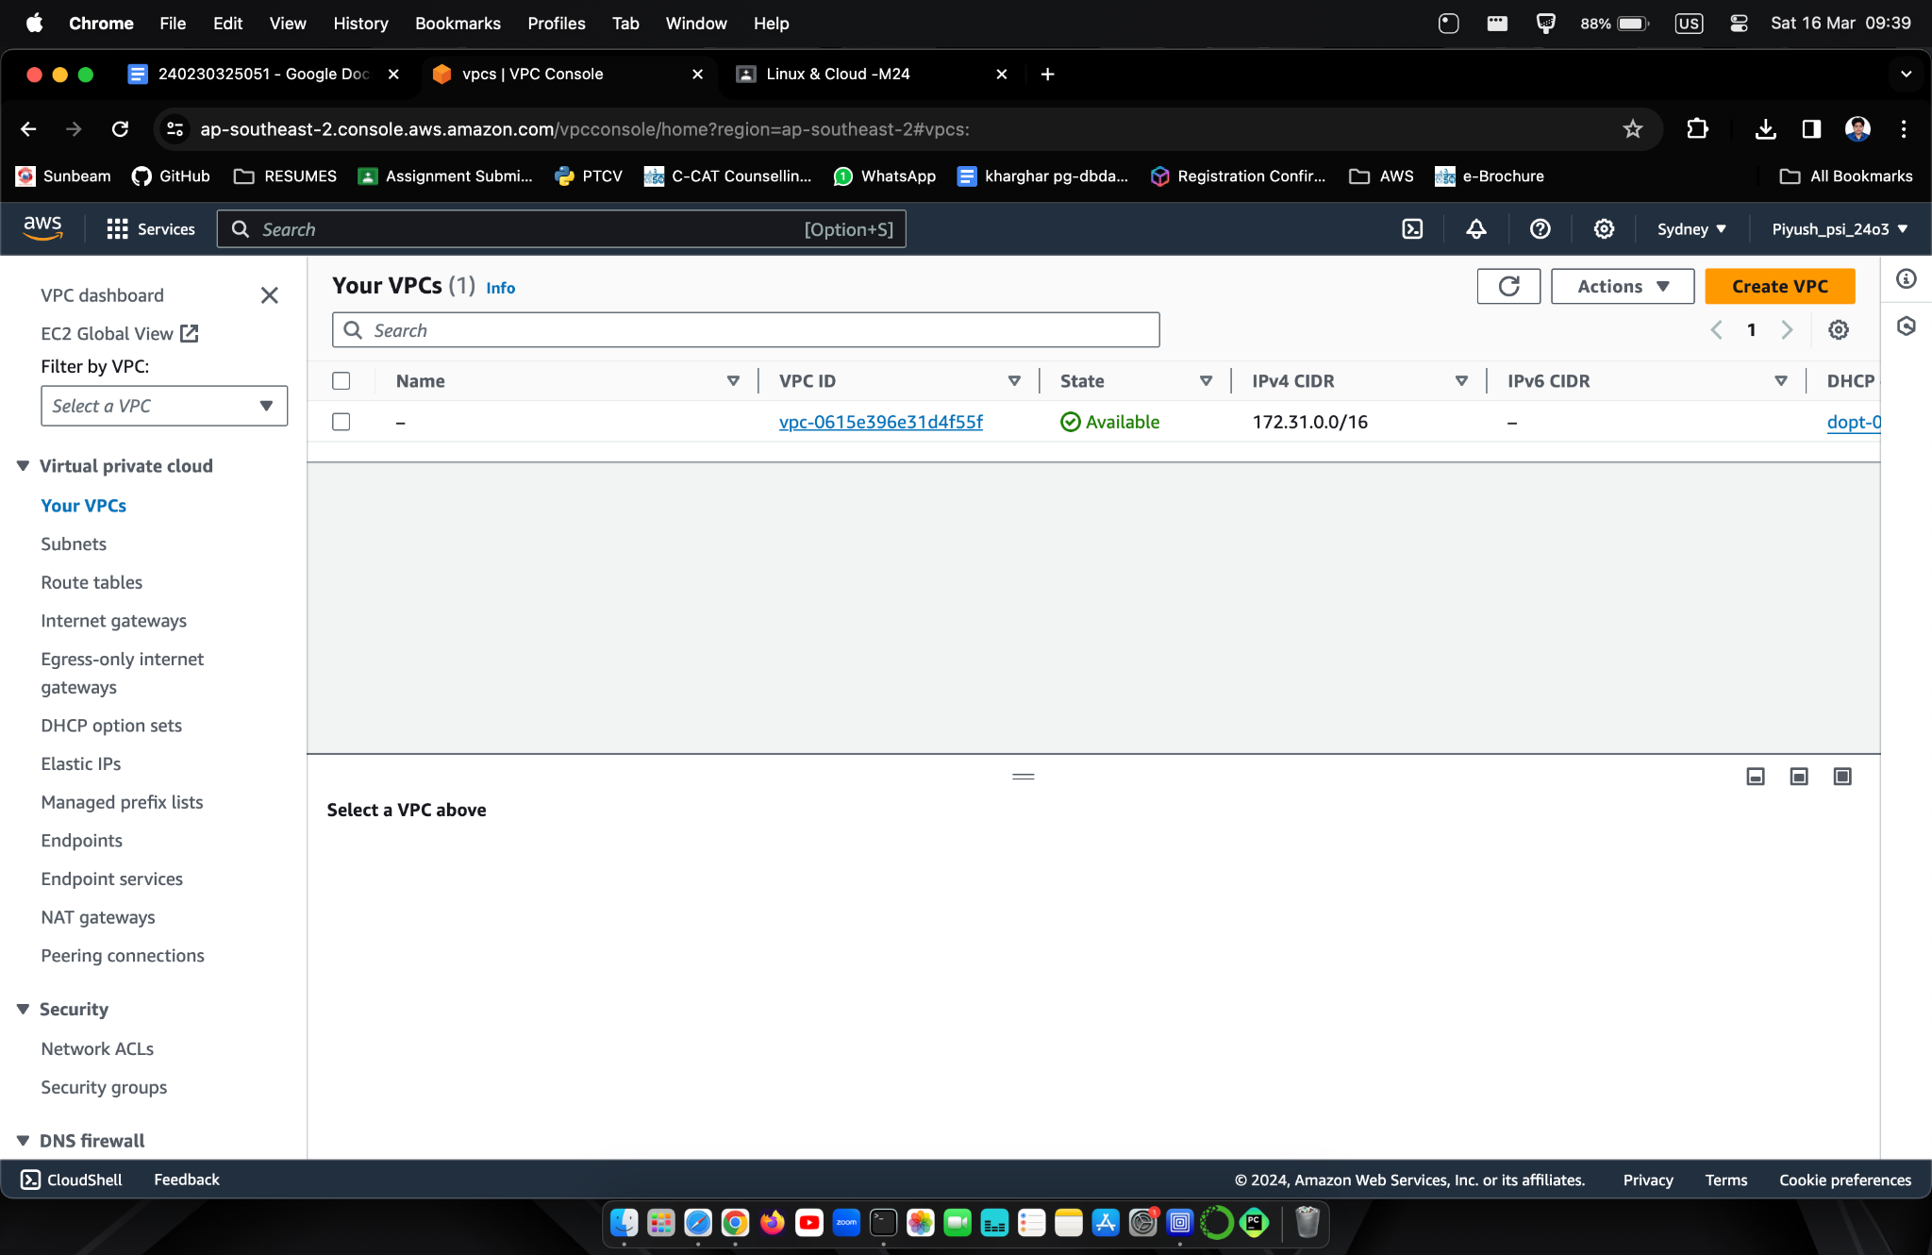

**Enter Name and IPv4**

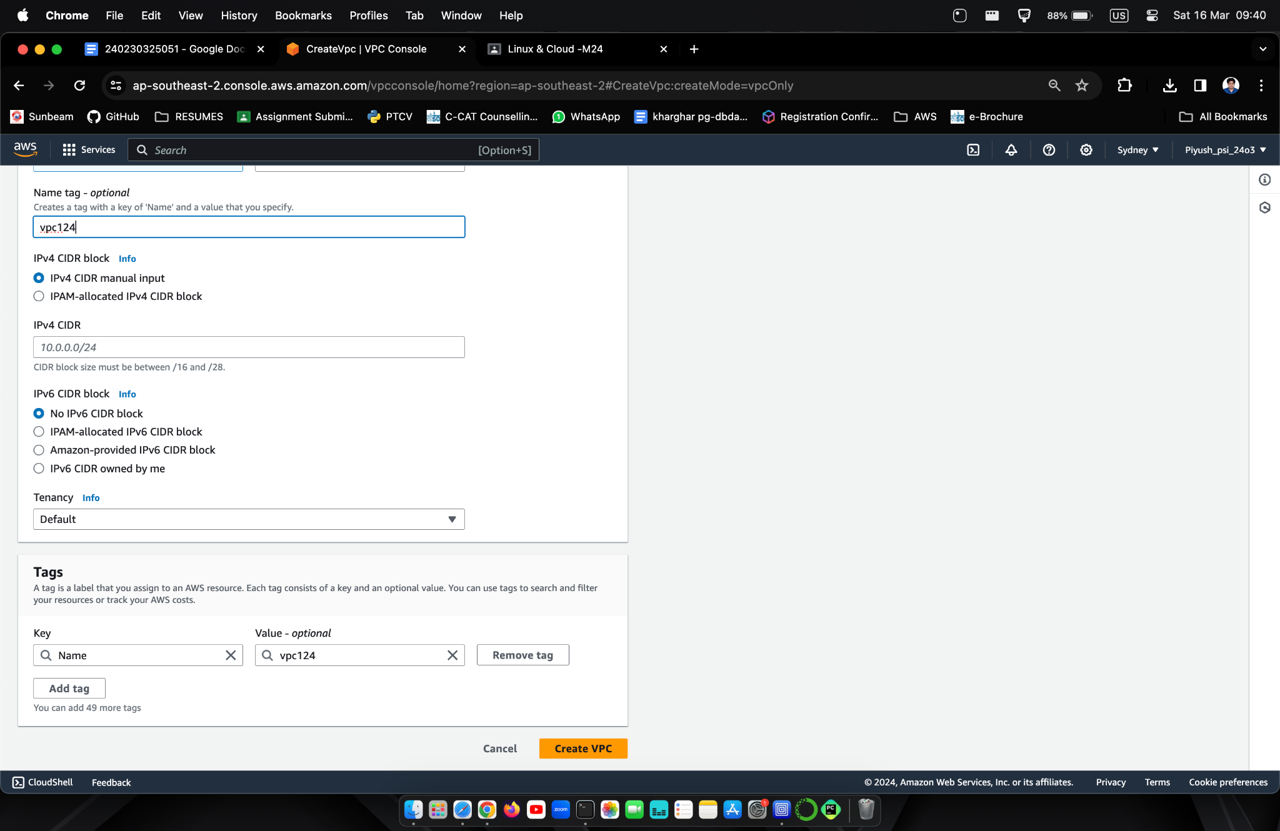

**Select Subnets > Create**

**Select VPC Created**

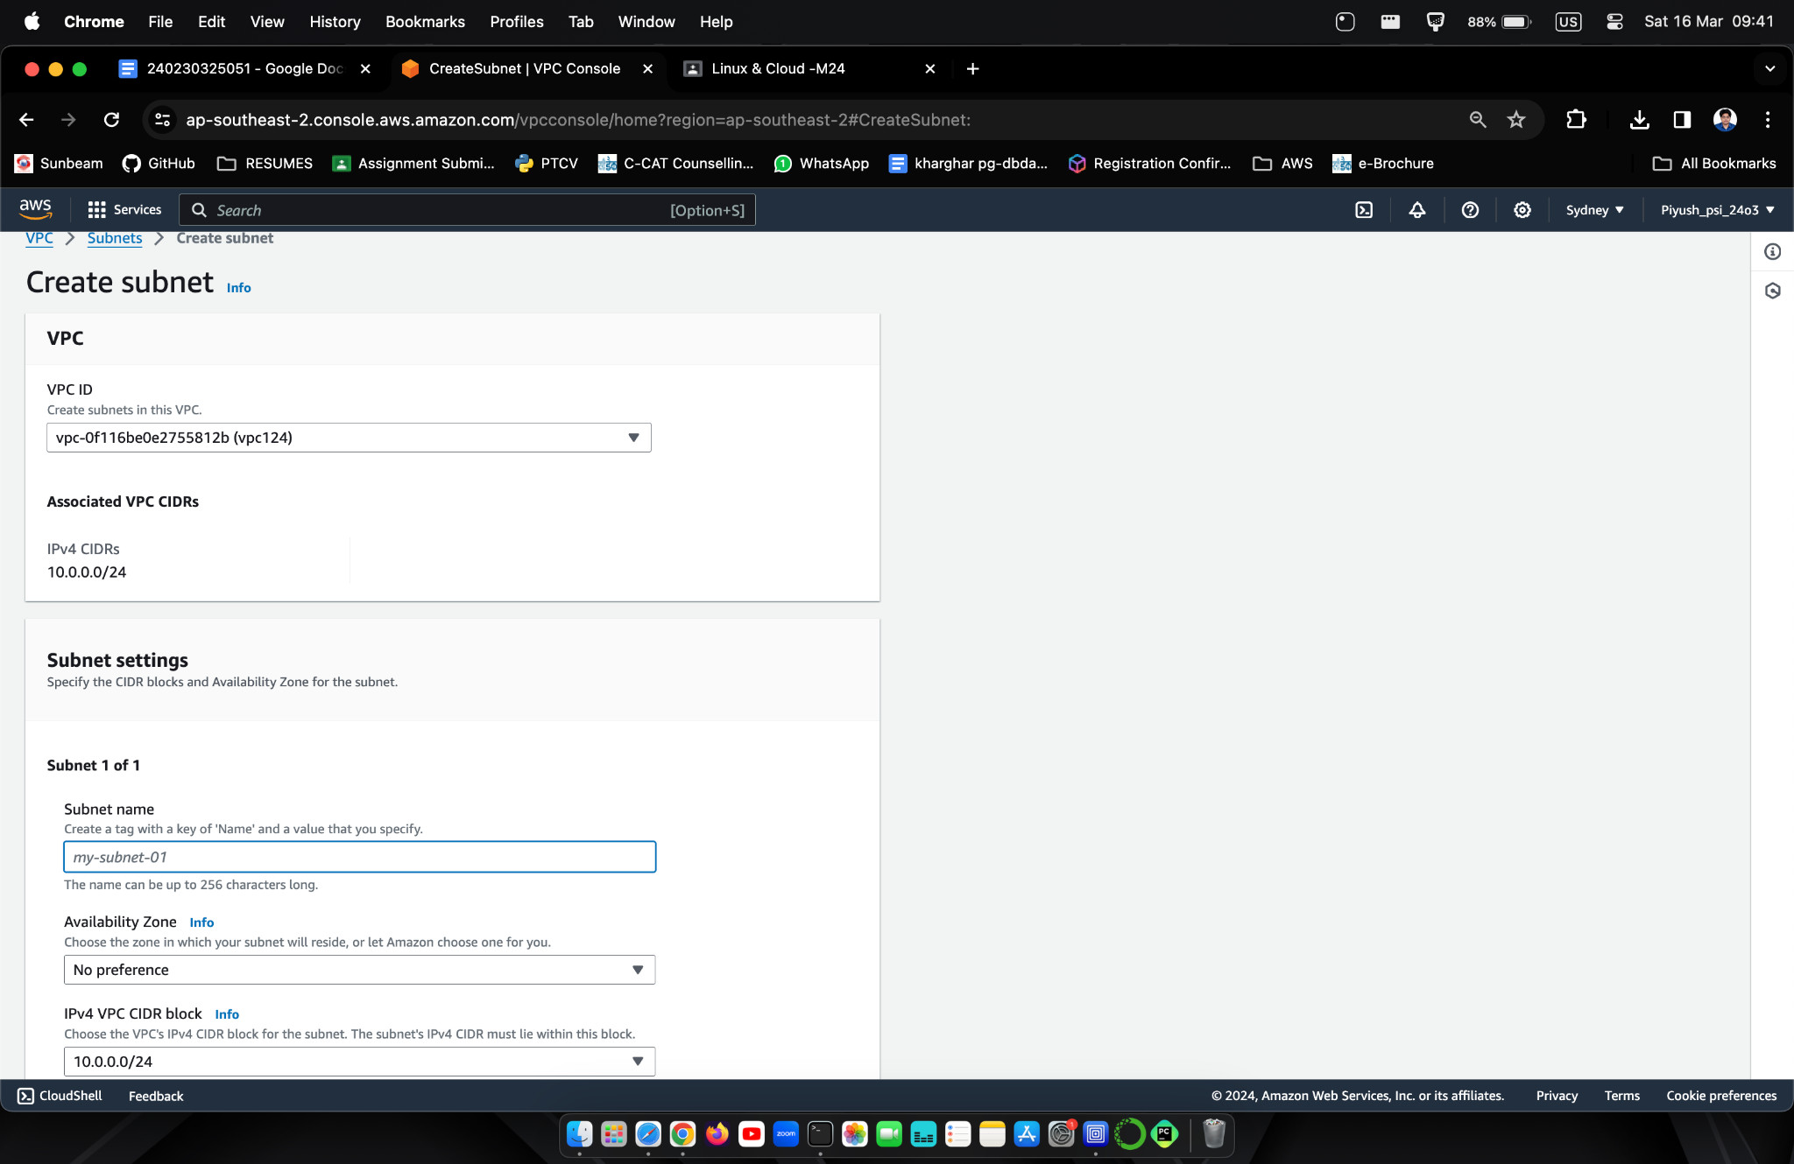

**Enter Details Create Subnet**

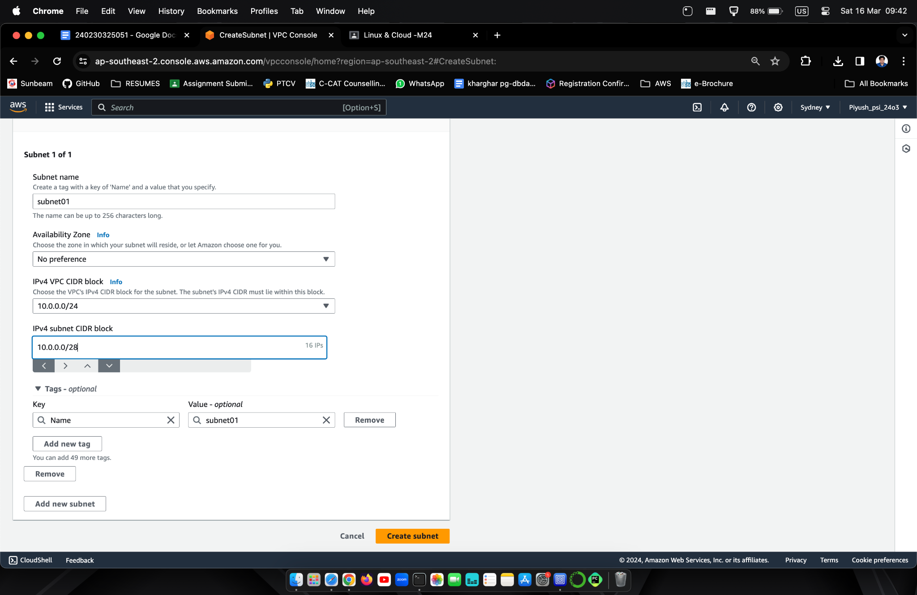

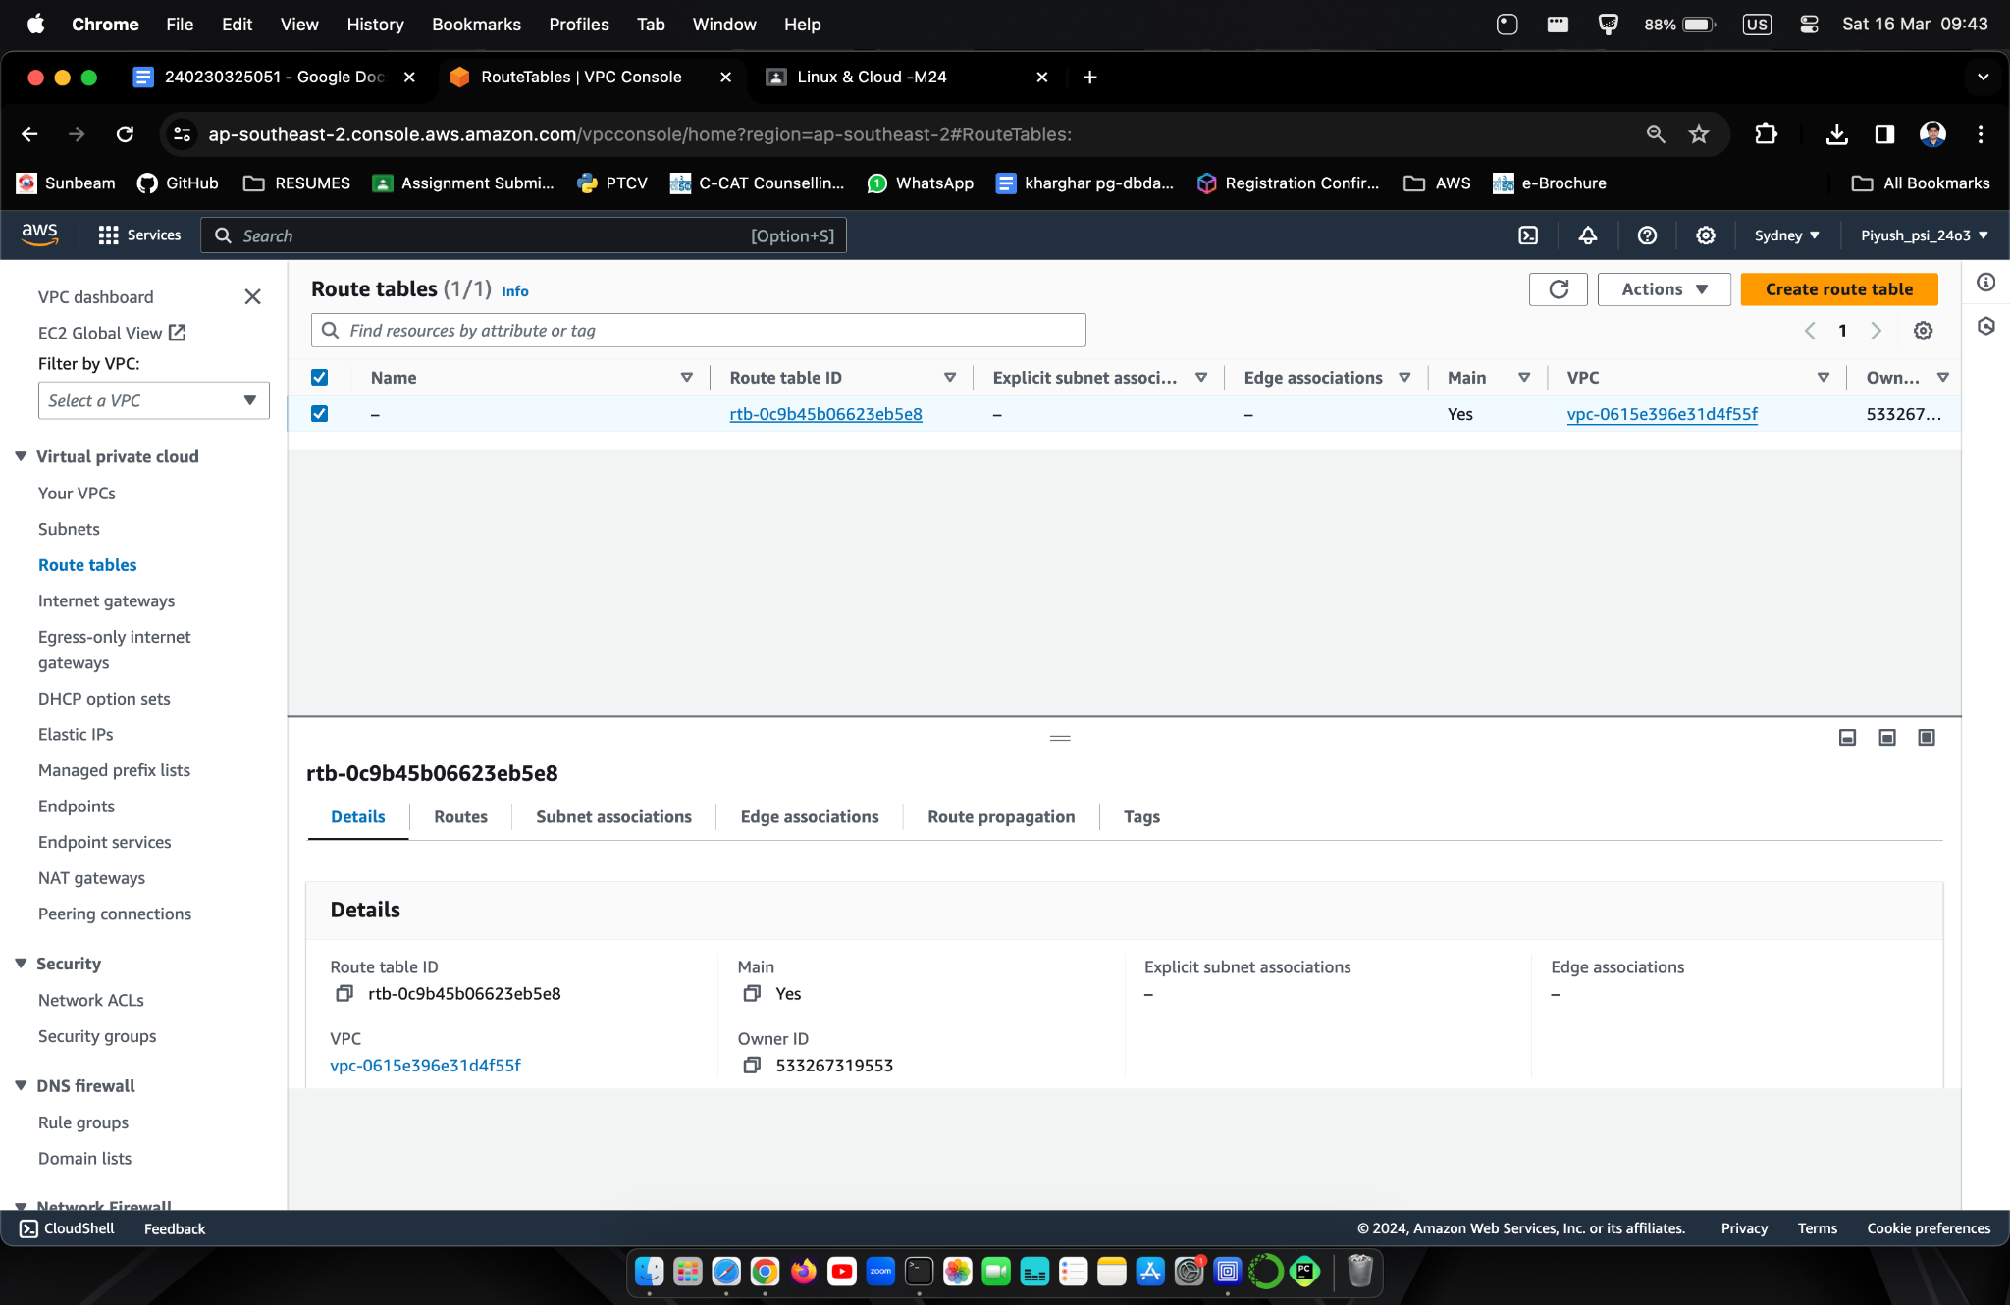

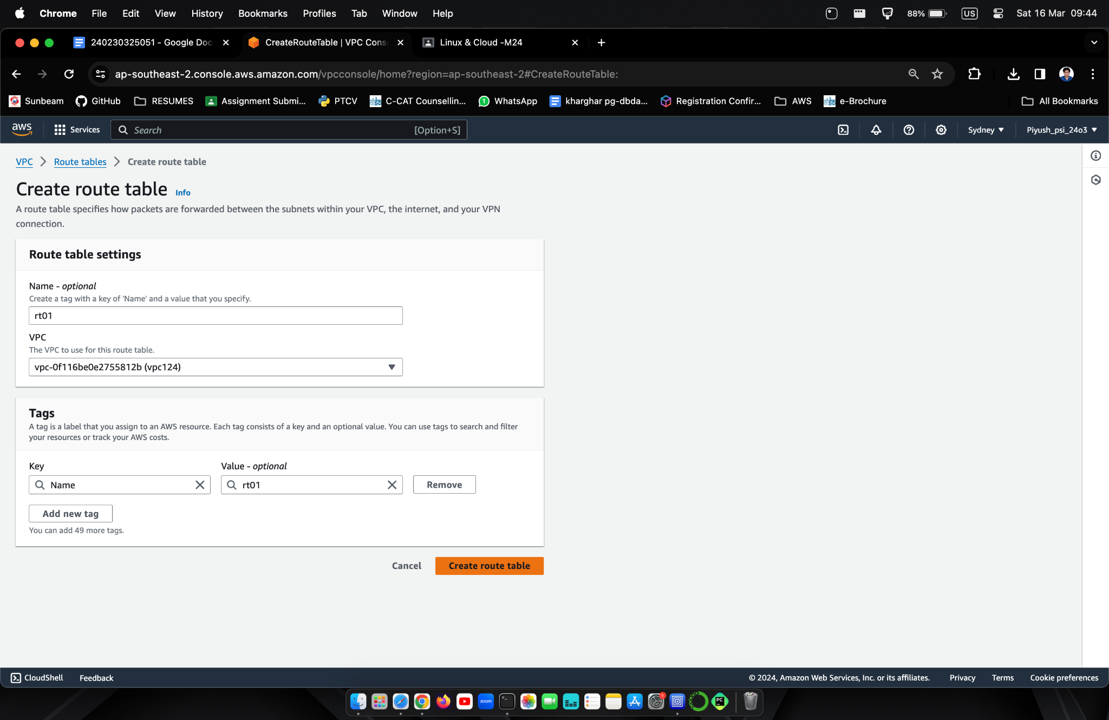

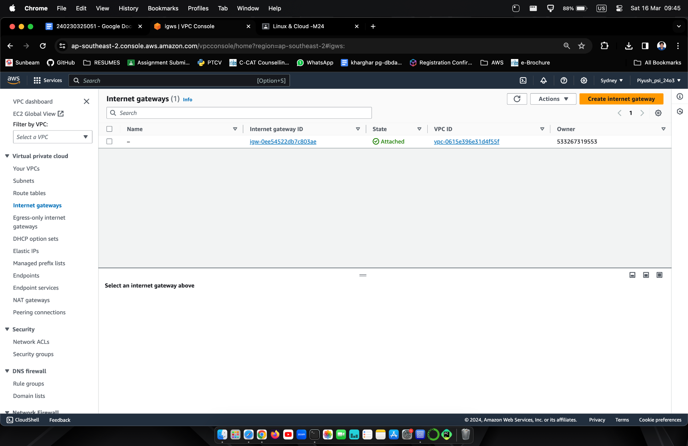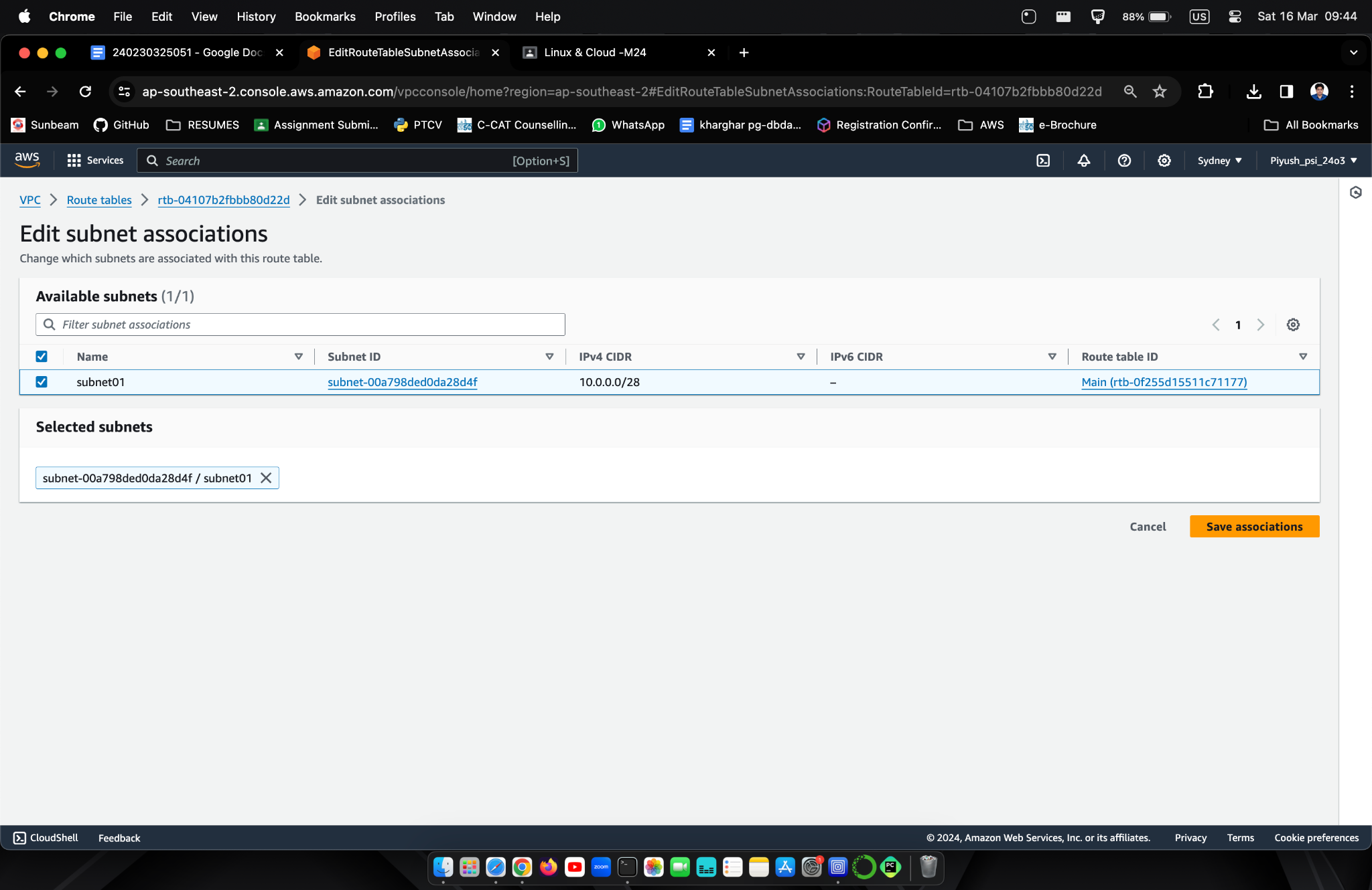

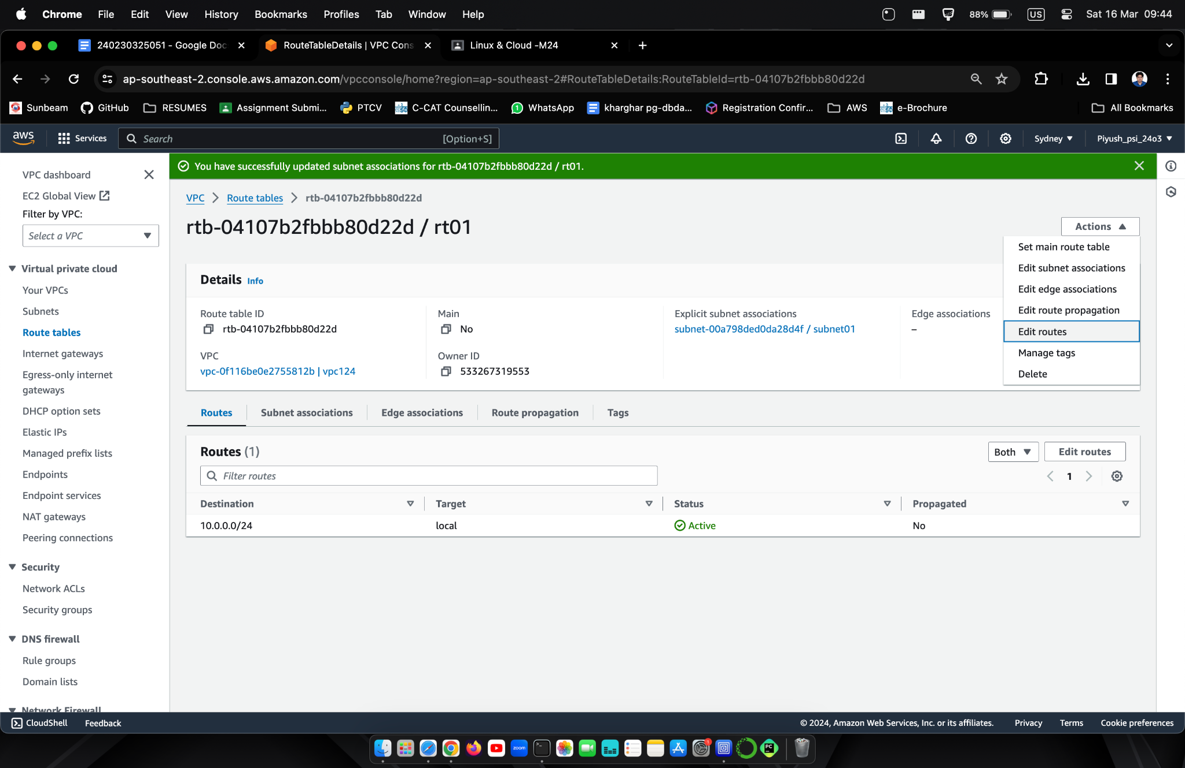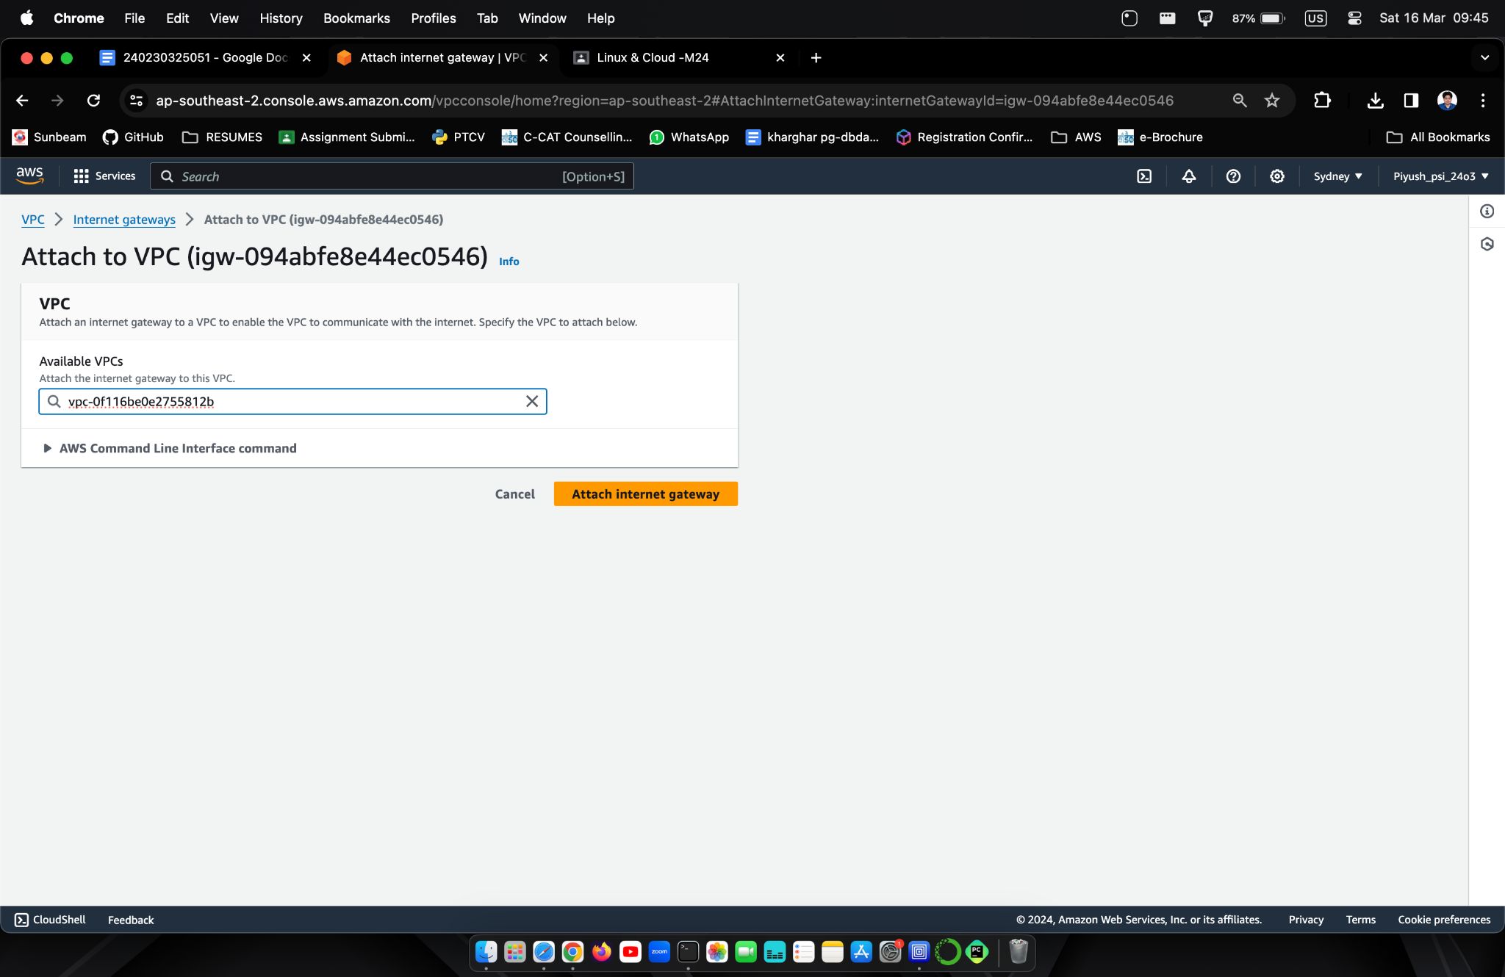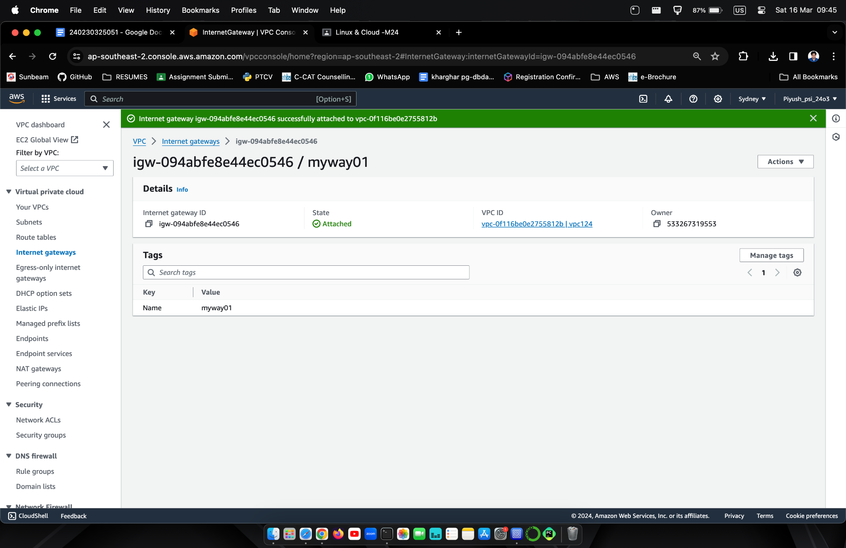

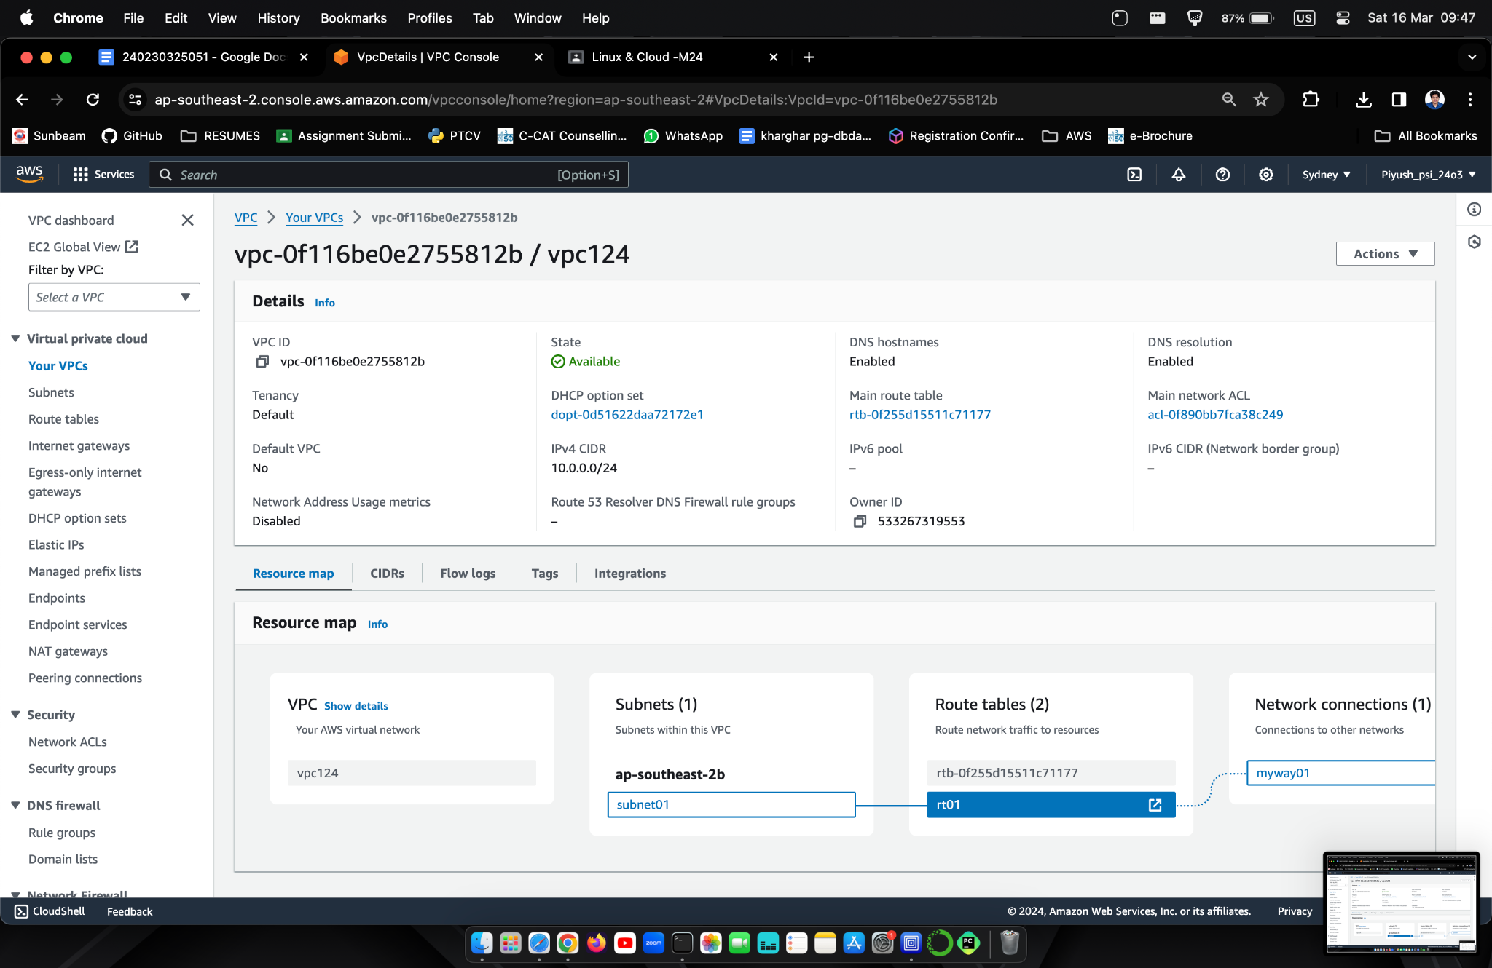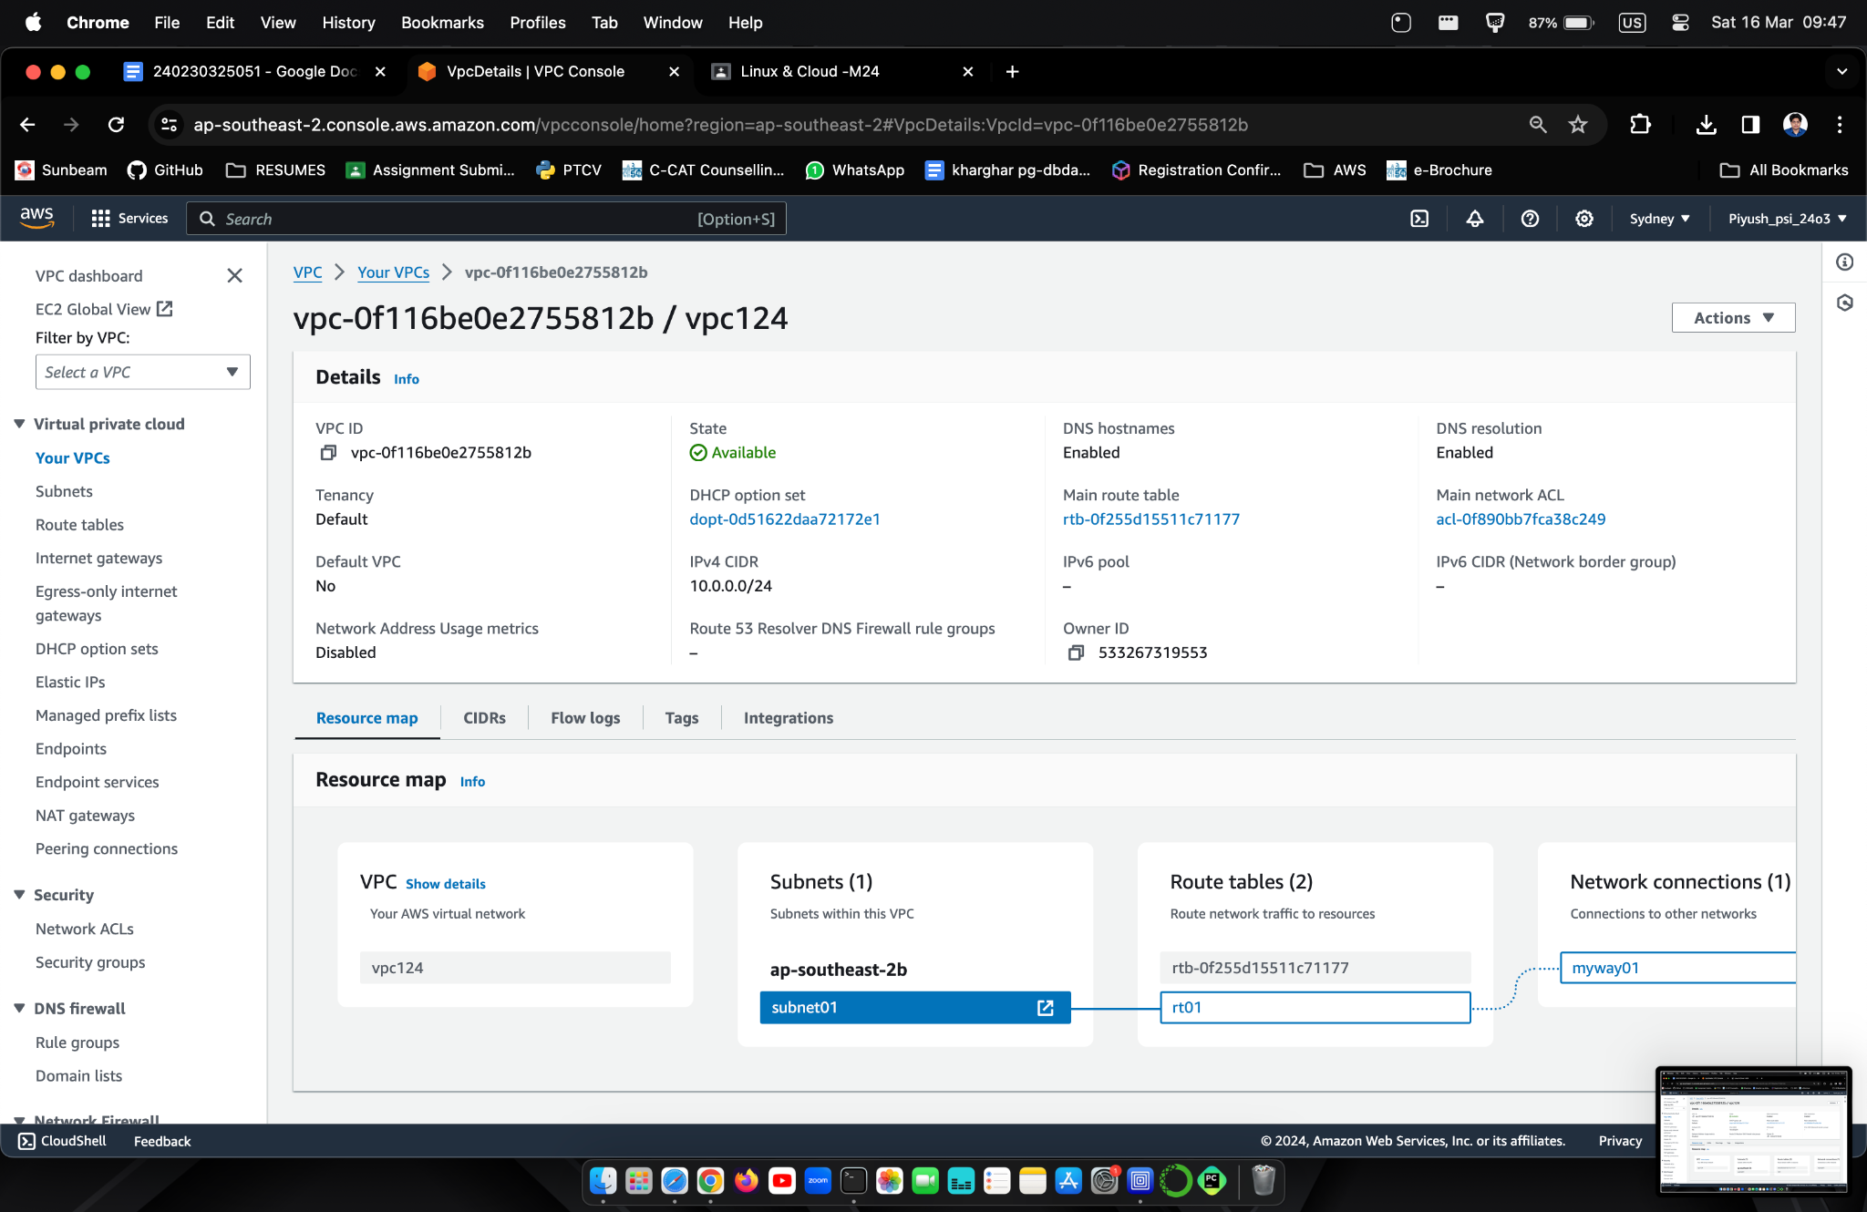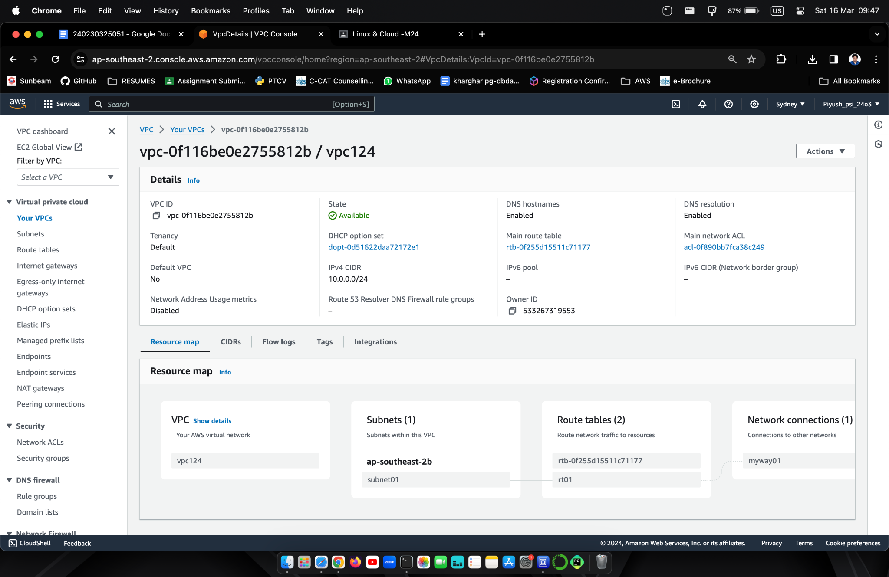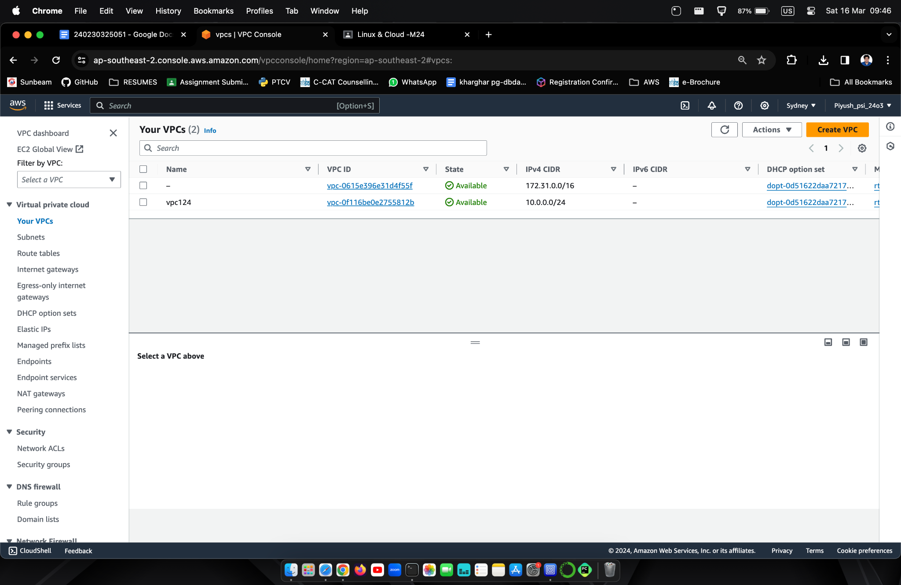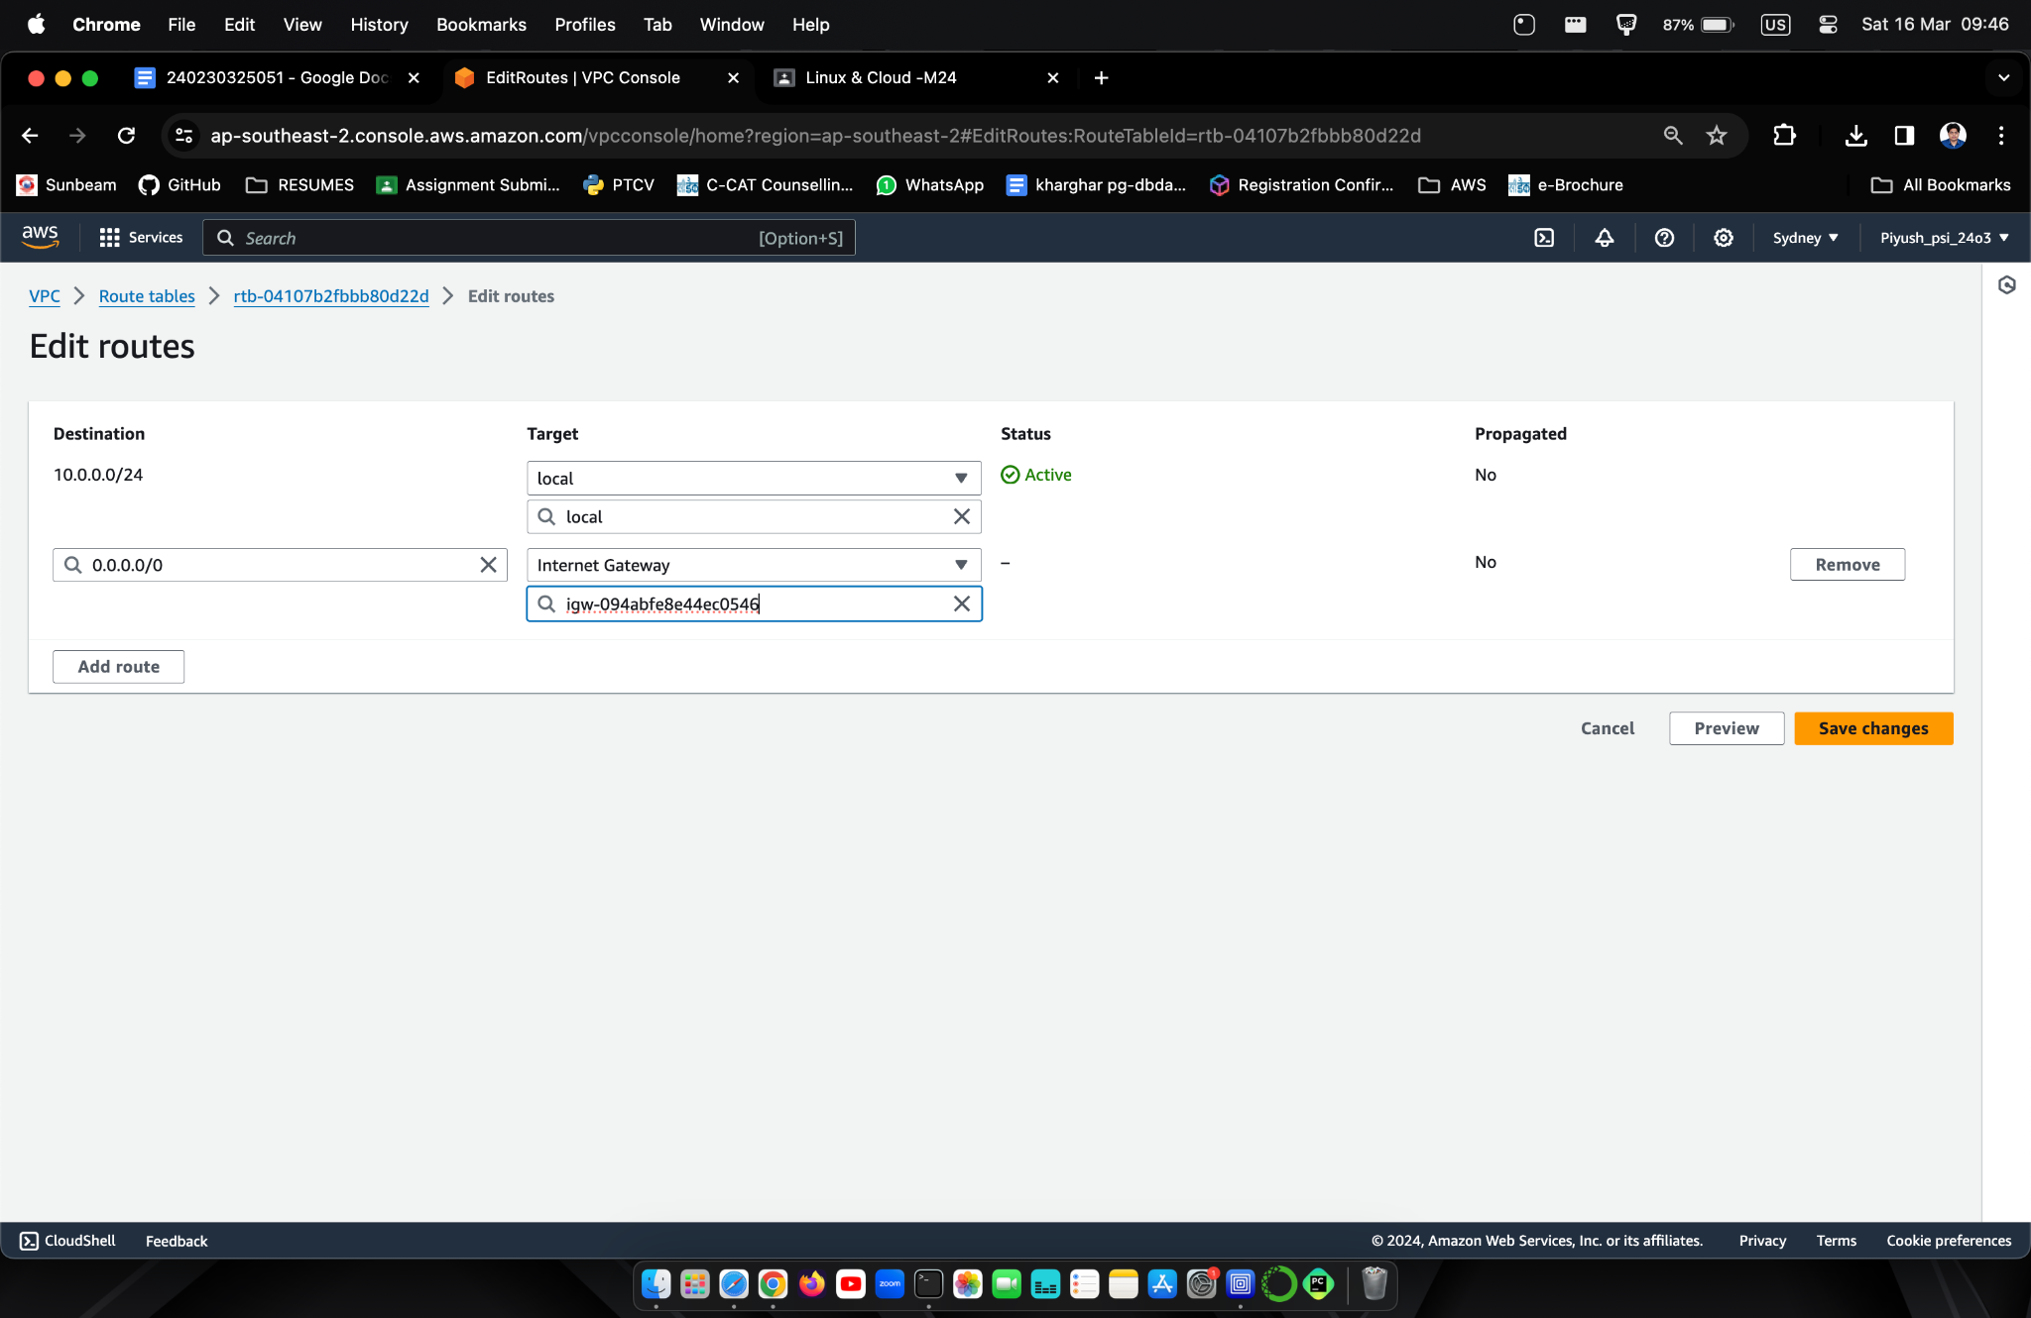

1. Write a shell script to check if a given year is a leap year.

Ans. Steps followed -

* First I created a directory named "met" to run and save all my programs.
* Then I entered the "met" directory using cd met.
* Then I created a .sh file named "leapyear.sh" via nano command

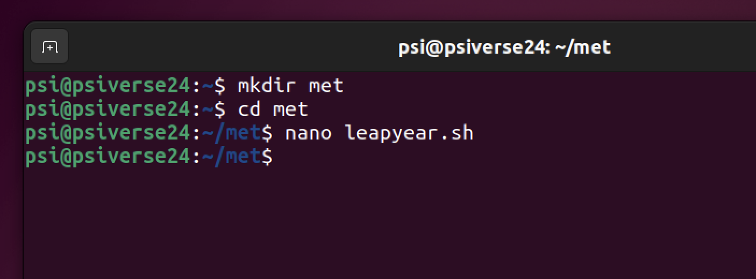

Made program to check if entered year is leap year

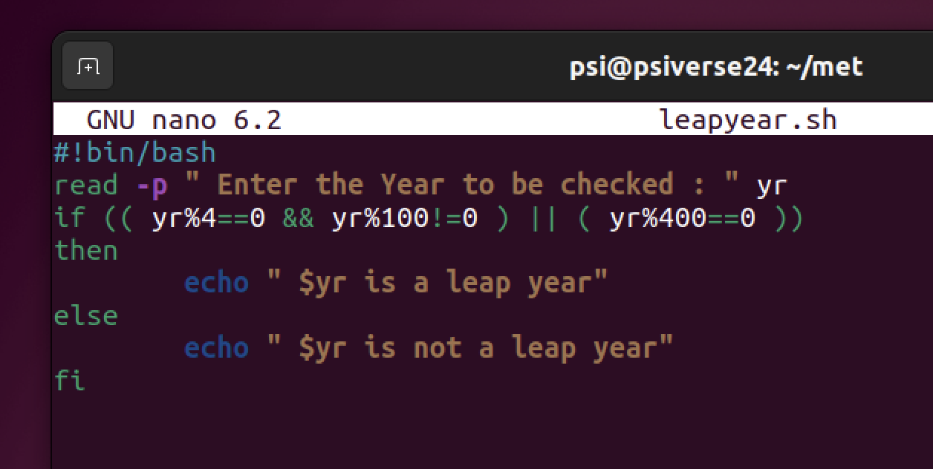

Saved File using ˆS and exit it using ˆX

Run Bash command with file name to execute file.

1. Write shell script to print fibonacci series up to given number

Ans Run nano fibonacci.sh to create .sh file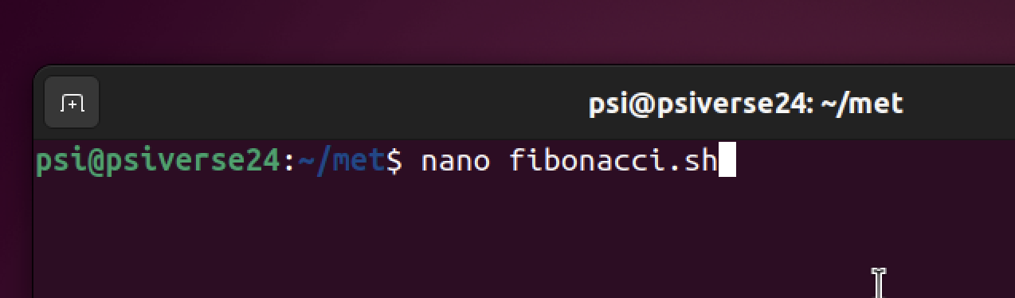

Made program to print fibonacci series for entered number

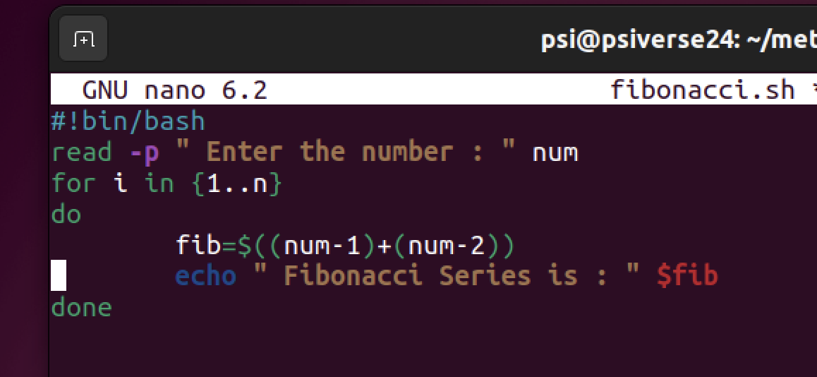

Run Bash command with file name to execute file.

1. Answer 3